

**REPORT OF**

**INDUSTRIAL TRAINING**

At

**CMPDI**

(A Subsidiary of CIL)

(A Mini Ratna Company)

Submitted by

**SHREYA GUPTA**



Birla Institute of Technology, Mesra

Deemed university in Ranchi, Jharkhand

CERTIFICATE

This is to certify that Mrs. Shreya Gupta, a student of BIRLA INSTITUTE OF TECHNOLOGY, MESRA has successfully completed 2 months of internship from 17th May to 17th July,2023 under Innovation Cell, ICT Division. During the period she worked on the data of Cardio Vascular Disease and contributed in healthcare. During the period of her internship with us she was found punctual, hardworking and creative.

**Mr. Ashish Das Mr. B.A. Reddy**

**Manager (Mining) GM(ICT),CMPDI**

**Innovation Cell/ICT Division**

**ACKNOWLEDGEMENT**

I would also like to thank GM (HRD) Mr. R.K. Mohapatro, GM (ICT) Mr. B. A Reddy, Mr. Suresh Behera as well as my esteemed Mentors Mr. Ashish Das and Mr. Himanshu Shekhar Sharma who has contributed so much for successful completion of my Industrial Training by their thoughtful reviews and valuable guidance.

I would like to extend my appreciation to my colleagues and friends for their encouragement and assistance during the project. Their feedback and discussions have been invaluable in refining my ideas and improving the quality of my work.

**SHREYA GUPTA**

# Table of Contents

Table of Contents 3

Investigating Factors Associated with Cardiovascular Disease and Building a Predictive Model 4

1.INTRODUCTION: 4

KEY FACTS 4

2.PROBLEM STATEMENT 4

3.OBJECTIVE 5

4.METHODOLOGY 5

5. DATA COLLECTION 5

5.1INPUT FEATURES 6

5.2 DESCRIPTIVE ANALYSIS OF FEATURES 6

5.3 VARIANCE 7

6. PROCESSING OF DATA 8

7. DATA CLEANING 8

8.VISUALIZATION OF VARIOUS FACTORS (EDA) 10

8.1 Age Factor 10

8.2 Blood Pressure 14

8.3 BMI CLASS 18

8.4 BLOOD PRESSURE 22

8.5 bmi range 23

Lifestyle changes summary 23

8.6 HEAT MAP 26

9. DATA PREPARATION FOR MODEL MAKING. 27

Removing outliers 27

10.Predicting and Modelling 28

1.Logistic regression 28

2.DECISION TREE 31

3.Random forest 32

11.CONCLUSION 33

12.LEARNING 34

13.BIBLIOGRAPHY 35

# **Investigating Factors Associated with Cardiovascular Disease and Building a Predictive Model**

**1.INTRODUCTION**:

CVD is a major global health concern and a leading cause of death worldwide. Analyzing the prevalence, incidence, and risk factors associated with CVD helps public health authorities understand the burden of the disease, allocate resources effectively, and develop targeted prevention and intervention strategies.

Analyzing cardiovascular disease allows for early detection and identification of individuals at high risk. By understanding the risk factors, such as high blood pressure, high cholesterol levels, or family history, healthcare professionals can implement preventive measures and lifestyle interventions to reduce the risk of developing CVD. This includes promoting healthy behaviors, encouraging regular check-ups, and providing appropriate medical treatments.

Analysis of cardiovascular disease helps in evaluating treatment strategies and management approaches. By studying the effectiveness of different medications, interventions, and surgical procedures, healthcare professionals can refine treatment protocols and improve patient outcomes. It also enables monitoring of disease progression, assessing the response to treatment, and adjusting therapies as needed.

### **KEY FACTS**

Cardiovascular diseases (CVDs) are the leading cause of death globally.

An estimated 17.9 million people died from CVDs in 2019, representing 32% of all global deaths. Of these deaths, 85% were due to heart attack and stroke.

Over three quarters of CVD deaths take place in low- and middle-income countries.

Out of the 17 million premature deaths (under the age of 70) due to noncommunicable diseases in 2019, 38% were caused by CVDs.

Most cardiovascular diseases can be prevented by addressing risk factors such as tobacco use, unhealthy diet and obesity, physical inactivity and harmful use of alcohol.

It is important to detect cardiovascular disease as early as possible so that management with counselling and medicines can begin.

## **2.PROBLEM STATEMENT**

Understanding the Impact of Risk Factors on Cardiovascular Disease Outcomes:

1. How do various risk factors, such as hypertension, smoking contribute to the development and progression of CVD?

2.How can we assess the impact of lifestyle modifications, such as diet and exercise, in preventing or managing cardiovascular diseases?

3.How can we better quantify the risk associated with specific risk factors and develop risk prediction models for improved cardiovascular disease prevention?

## **3.OBJECTIVE**

One objective is to monitor the prevalence, incidence, and trends of cardiovascular diseases within a population. This helps public health authorities and researchers understand the burden of CVD, identify high-risk groups, and track changes over time. It enables the development of targeted interventions and the evaluation of their effectiveness.

## **4.METHODOLOGY**

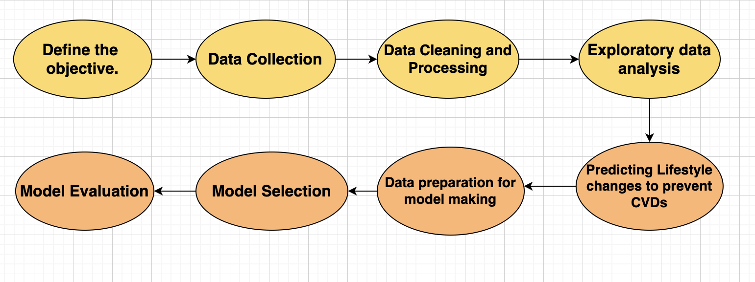

## **5. DATA COLLECTION**

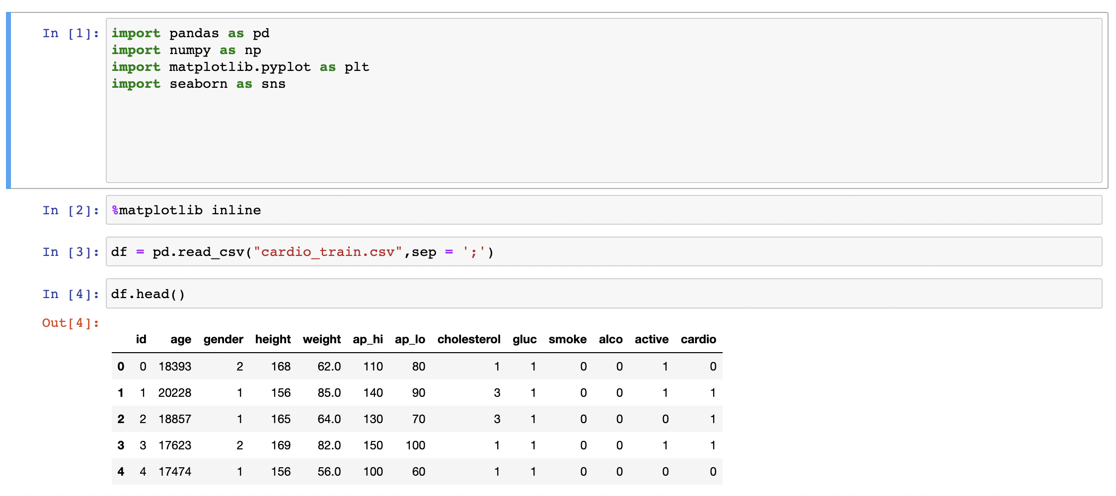

### **5.1 INPUT FEATURES**

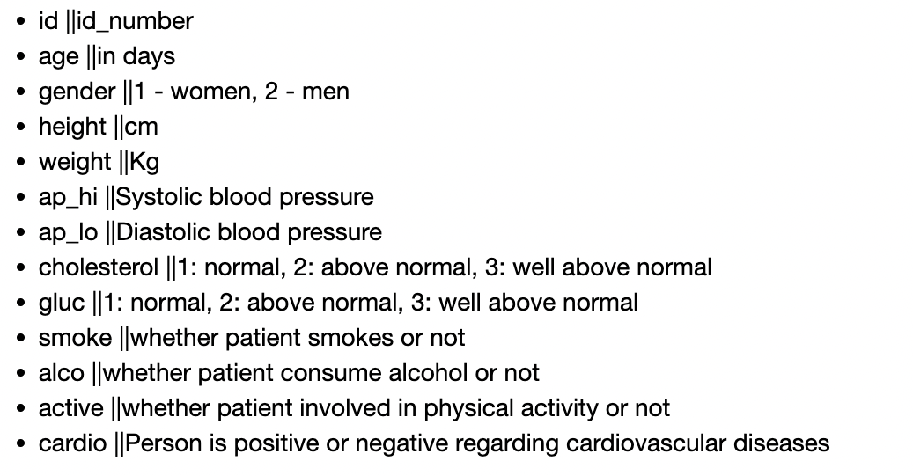

### **5.2 DESCRIPTIVE ANALYSIS OF FEATURES**

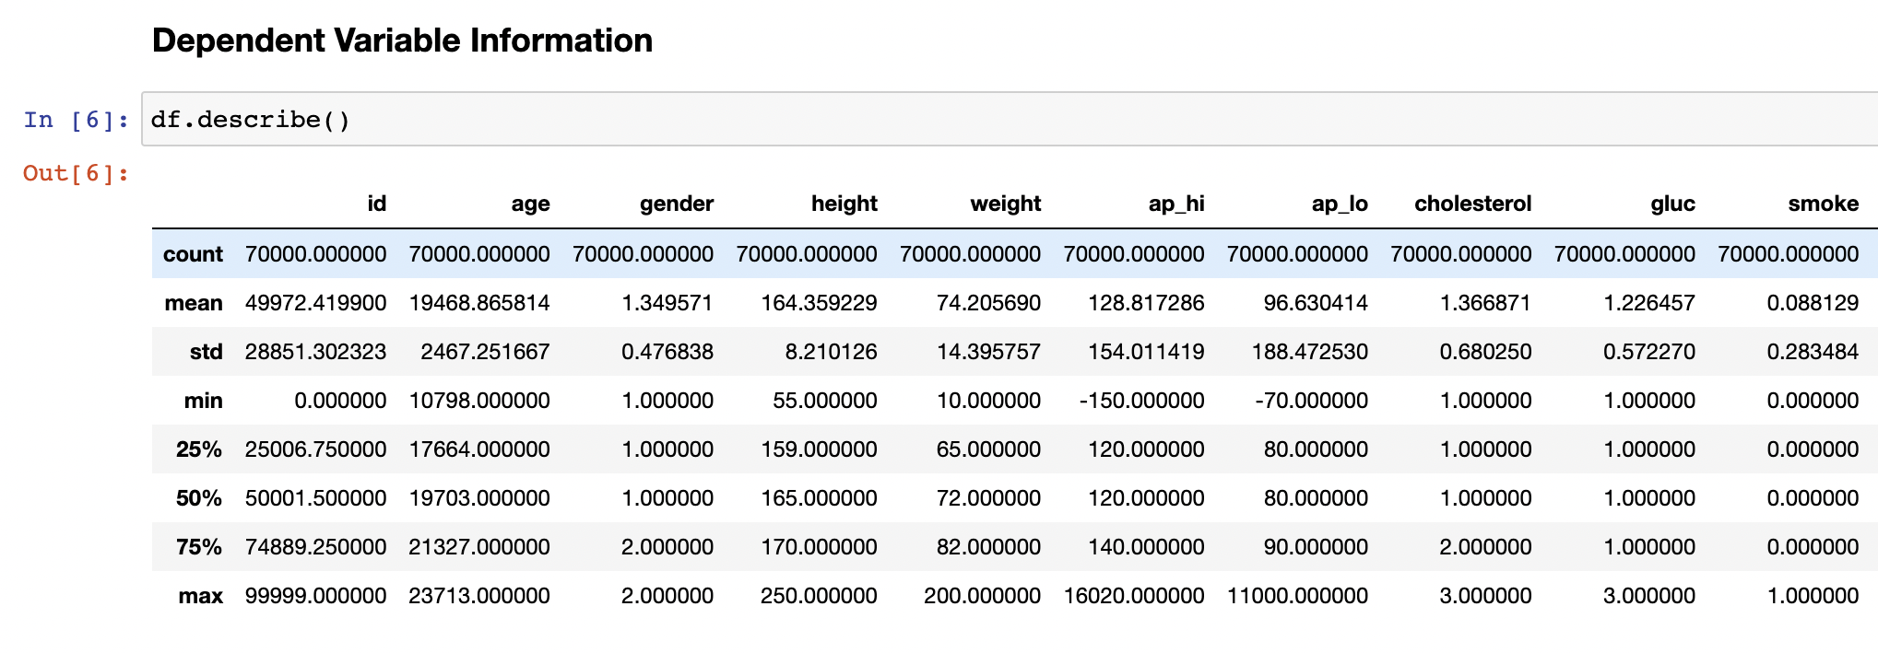

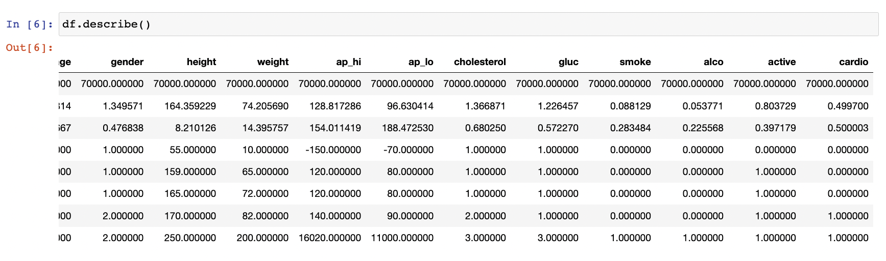

**Converting age in years and calculating bmi.**

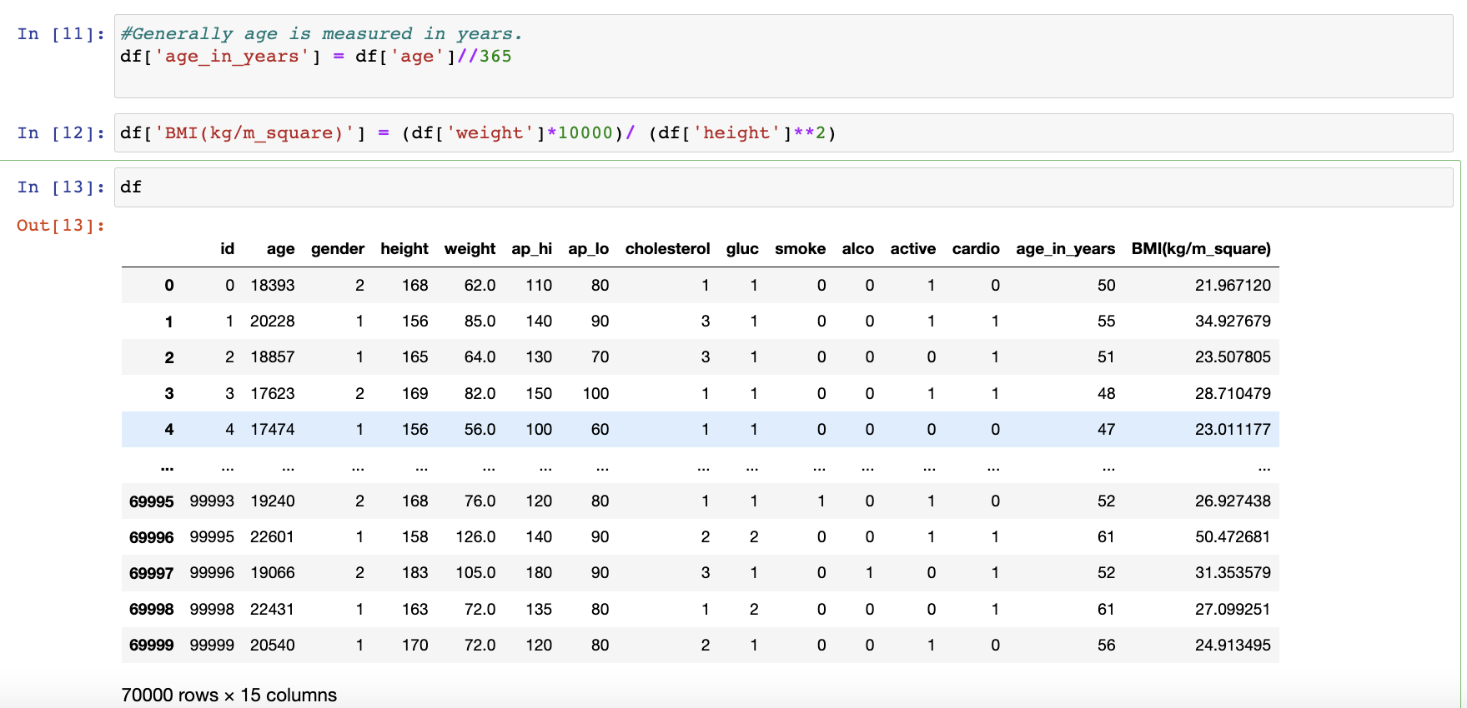

### **5.3 VARIANCE**

Variance is a statistical measure that quantifies the spread or dispersion of data points in a dataset. It measures the average squared deviation of each data point from the mean. The variance provides valuable information about the variability or diversity of the dataset.

Variance helps in understanding the distribution of data points. Higher variance indicates a greater spread, suggesting a wider range of values. Lower variance indicates a more clustered or concentrated distribution of data.

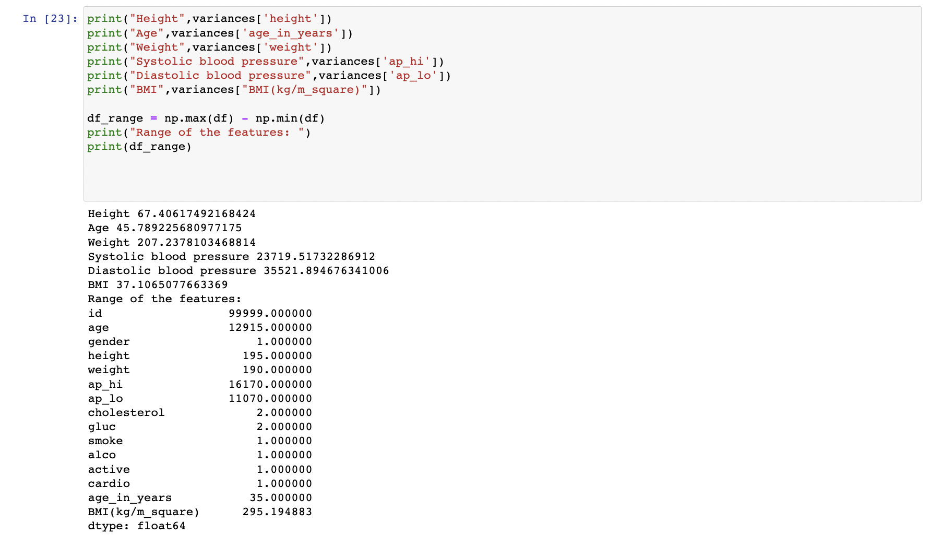

## **6. PROCESSING OF DATA**

Processing of data refers to the various operations and transformations applied to raw data in order to extract meaningful information, draw insights, and prepare it for further analysis or use.

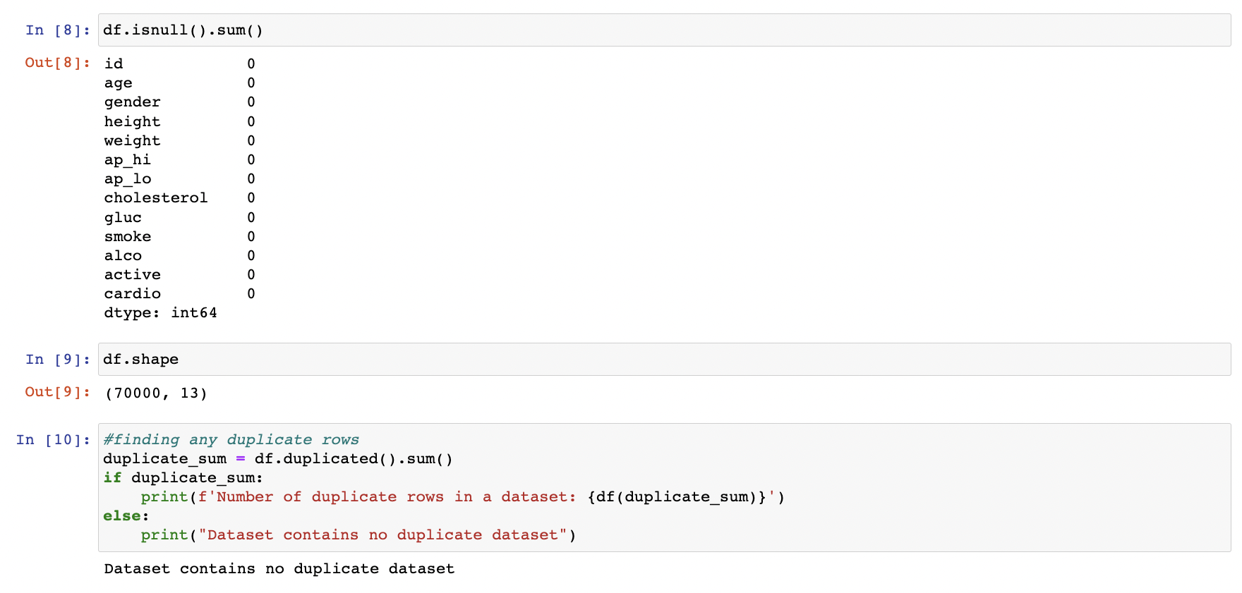

## **7. DATA CLEANING**

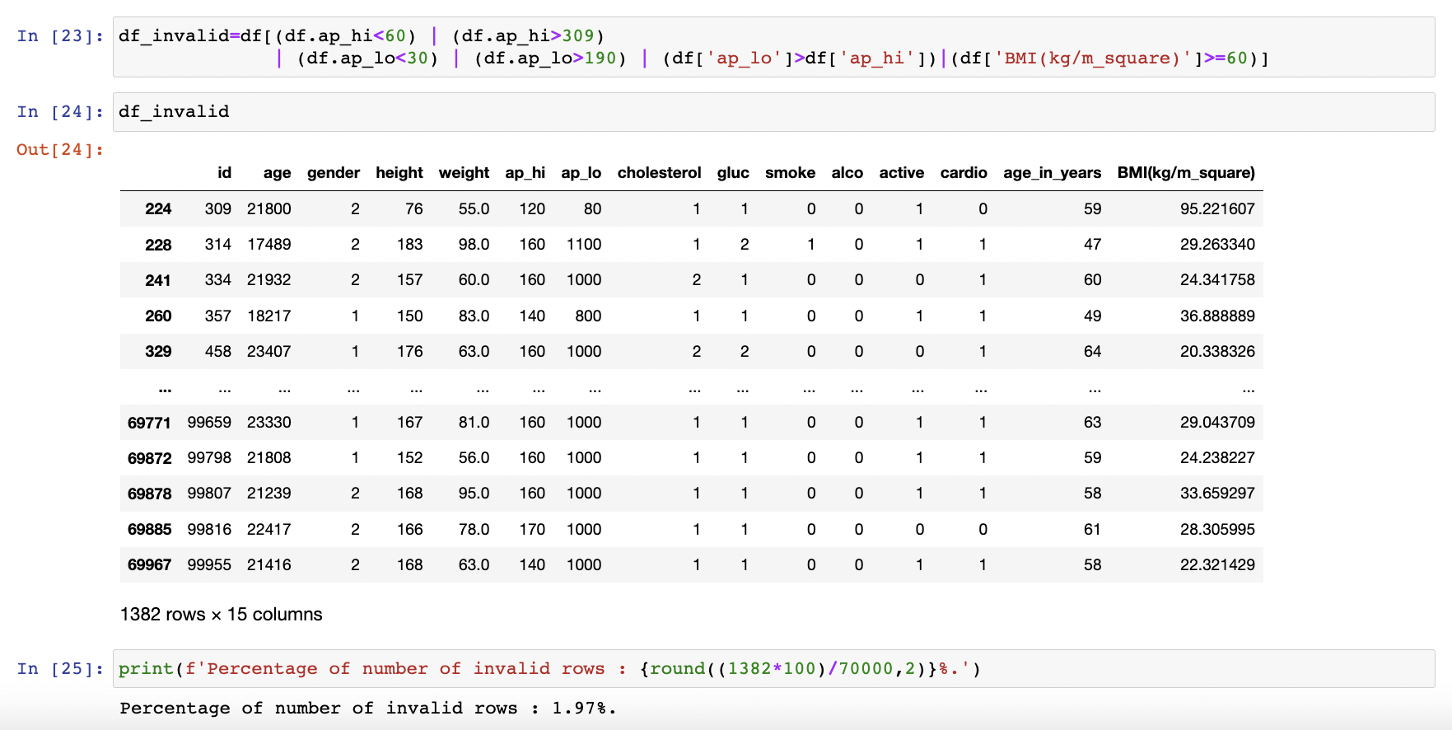

* + Valid systolic blood pressure should be greater than 60 and diastolic blood pressure should be greater than 30.
  + Valid systolic blood pressure should be less than 309 and diastolic blood pressure should be less than 190.
  + Systolic blood pressure should be greater than diastolic pressure.
  + BMI value should not be greater than 60.

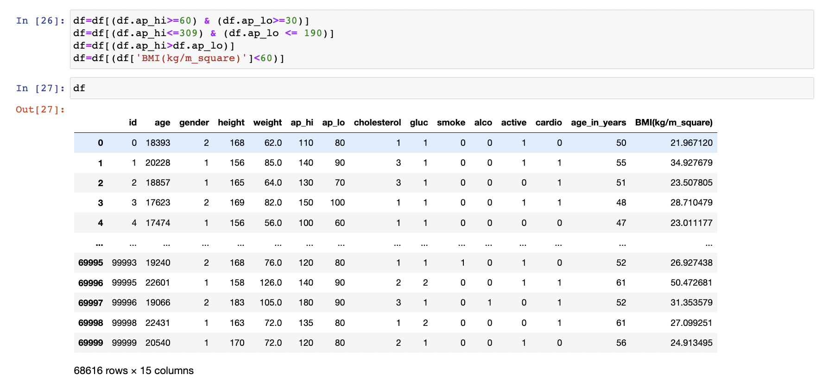

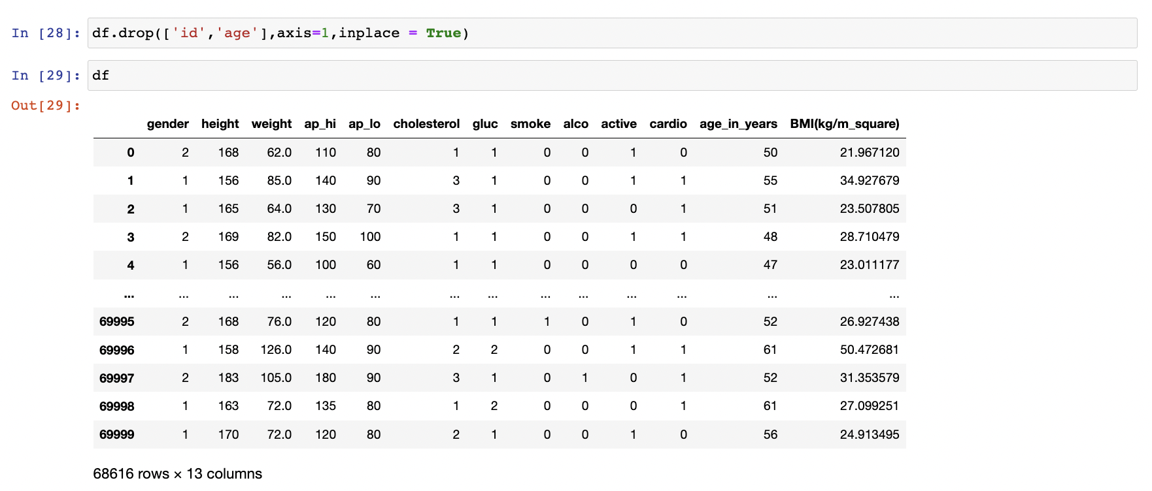

* + Dropped age and ID column.

## **8.VISUALIZATION OF VARIOUS FACTORS (EDA)**

### **8.1 Age Factor**

**1.On the basis of distribution**

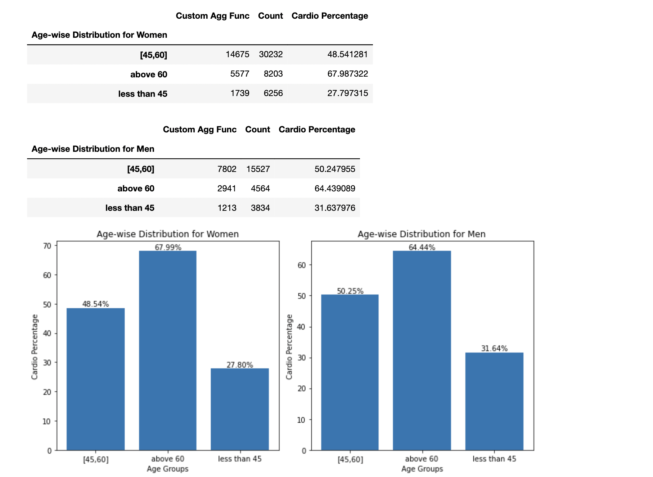 **Fig-1** Cardio percentage according to the age group for men and women.

**Conclusion:**

1.In the age group of <45: Men patients had 3.84 additional cases of cardio per 100 people compared to women patients according to risk difference.

2.In the age group of [45,60]: Men patients had 1.71 additional cases of cardio compared to men patients.

3.In the age group of >60: Women patients had 3.55 additional cases of cardio compared to men patients.

4.In both men and women: As age increases percentage of cardio patients also increases.

5.In the category of above 60, risk difference of women is more than men but in less than 45 years age more risk difference found in men.

6.Lifestyle changes: Men should take medications and precautions before 45 and women should go for regular checkup in the age group of [45,60] so that they can cure cardio problems in early ages to avoid permanent cardio diseases.

**2 Patients with high cholesterol on the basis of age factor.**

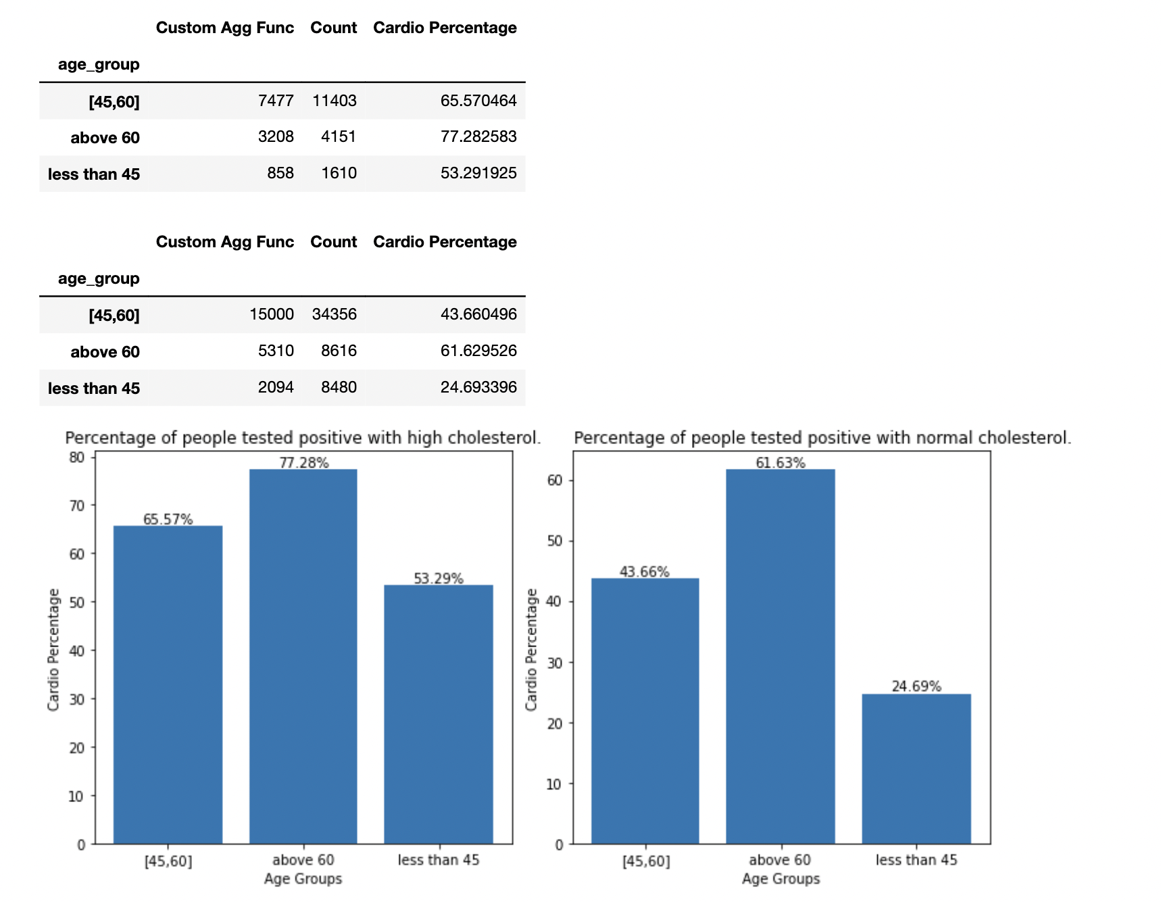

**Fig-2** Cardio percentage of people with high cholesterol according to the age group

**CONCLUSION:**

1.In this we can conclude that as age increases, patients with high cholesterol are more prone to cardio diseases.

2. In the age group of <45: Patients having high cholesterol are having 28.6 additional cases of cardio per 100 compared to normal cholesterol patients.

3. In the age group of [45,60]: Patients having high cholesterol are having 21.91 additional cases of cardio per 100 compared to normal cholesterol patients.

4.In the age group of >60: Patients having high cholesterol are having 15.65 additional cases of cardio per 100 compared to normal cholesterol patients.

5.Lifestyle changes -> Here we can see that young people with high cholesterol are more prone to cardio diseases. If one develops high cholesterol in young age that is <45, they should take medications and precautions immediately because in young ages it can be cured but as the age gets older complexity arises in many more things also.

**3.Patients with high cholesterol and bad lifestyle.**

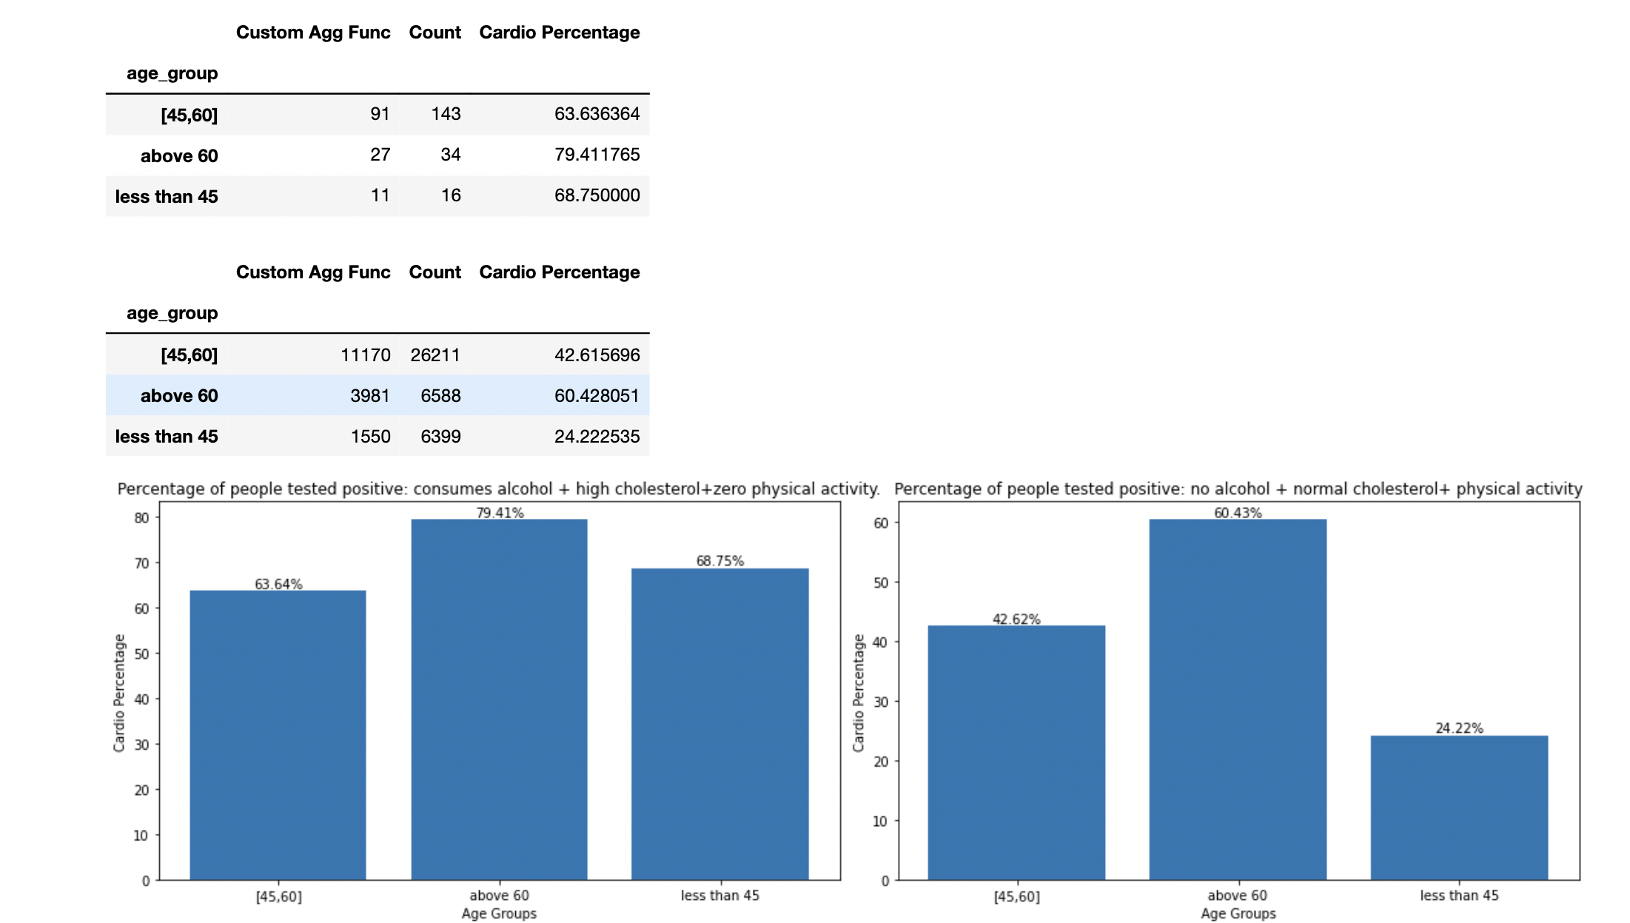

**Fig-3** Cardio Percentage of people with high cholesterol and bad lifestyle of consuming alcohol and inactive physically according to age group.

**Conclusion:**

1.In the age group of >60: Patients with high cholesterol who consumes alcohol and inactive physically are having 18.98 additional cases of cardio per 100 compared to normal patients.

2. In the age group of [45,60]: Patients with high cholesterol who consumes alcohol and inactive physically are having 21.02 additional cases of cardio per 100 compared to normal patients.

3. In the age group of <45: Patients with high cholesterol who consumes alcohol and inactive physically are having 44.53 additional cases of cardio per 100 compared to normal patients.

4.So, alcohol and physical activity plays key role in developing risk of cardiovascular diseases.

5.Lifestyle changes-> This implies that at young age behavioural factors matters a lot. Taking good diet and following good lifestyle by not consuming alcohol and involving in physical activity can reduce cardio patients by 44.53 cases per 100 in young ages.

**4. Patients with high cholesterol and glucose.**

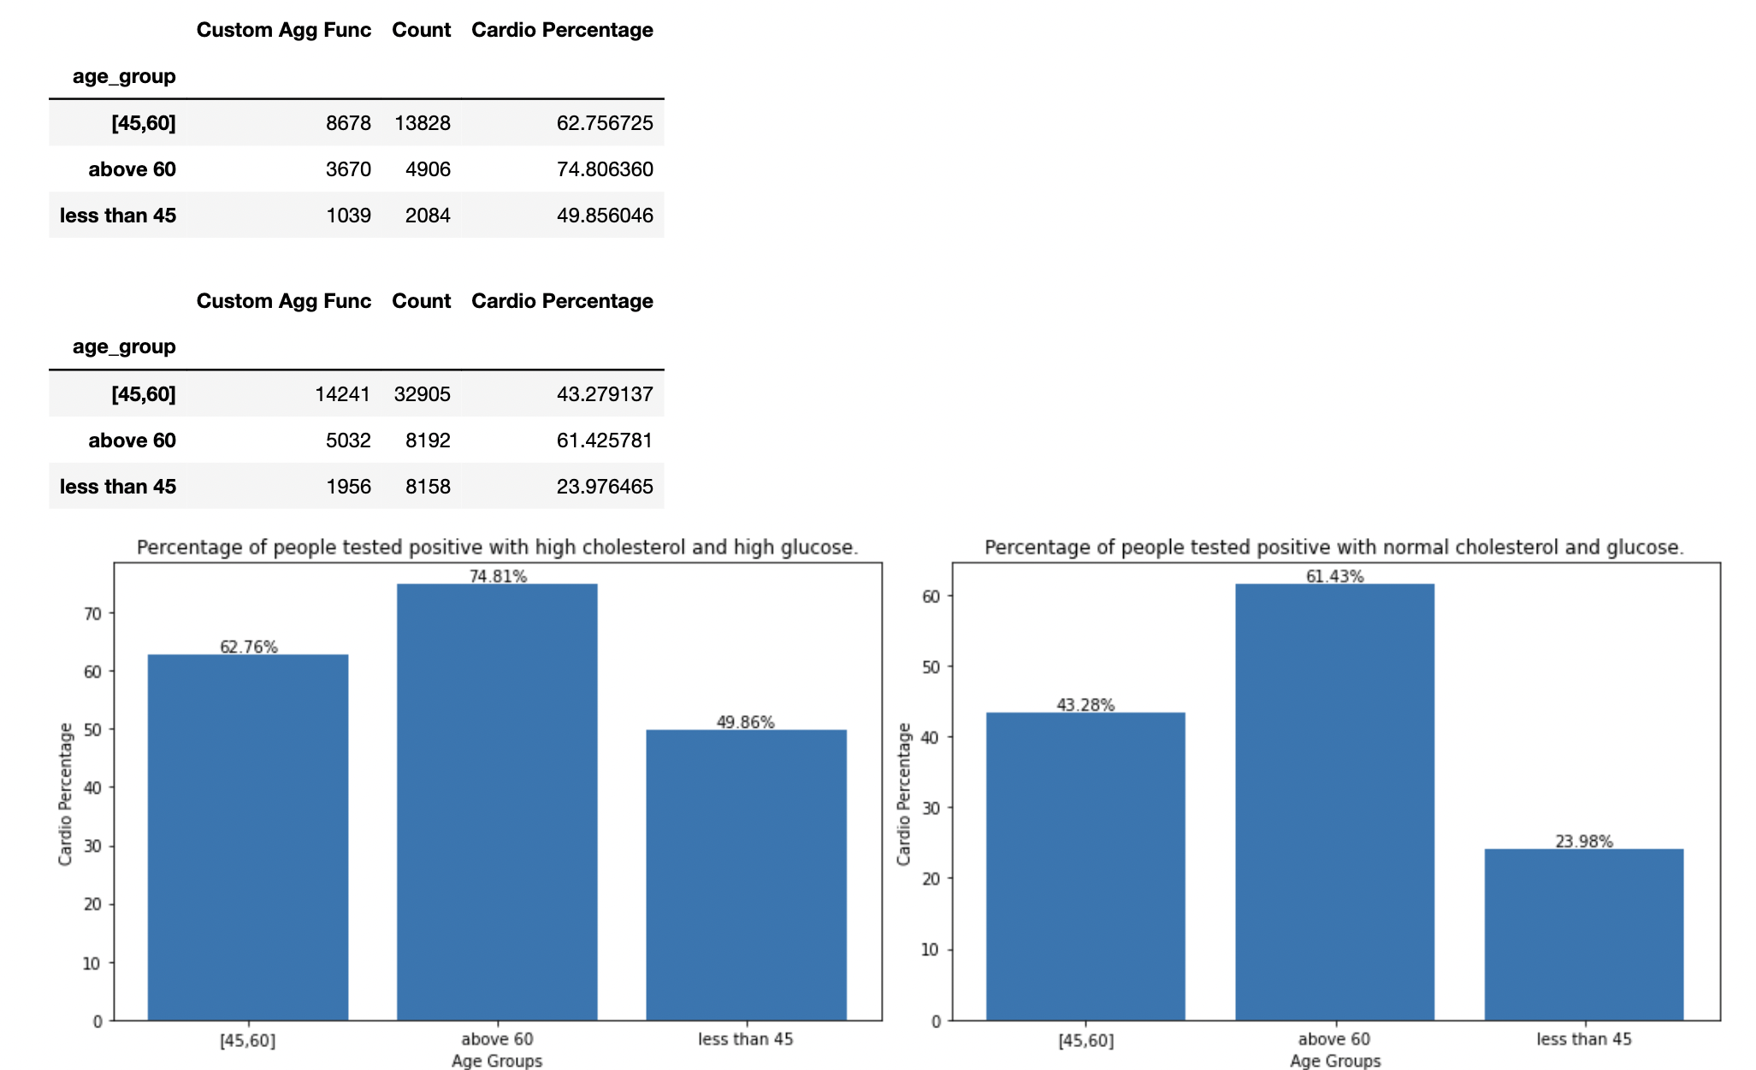

**Fig:4** Cardio percentage of people with high cholesterol and high glucose according to the age group.

**CONCLUSION:**

1.In the age group of <45: Patients having high cholesterol followed by high glucose are having 25.88 additional cases of cardio per 100 compared to normal patients.

2.In the age group of [45,60]: Patients having high cholesterol followed by high glucose are having 19.48 additional cases of cardio per 100 compared to normal patients.

3. In the age group of >60: Patients having high cholesterol followed by high glucose are having 13.38 additional cases of cardio per 100 compared to normal patients.

4.Lifestyle changes: At early ages, patients with high cholesterol followed by high glucose are more prone to cardio diseases than any other age. Lifestyle approach of good diet specifically for young age reduces the risk of permanent cardio problems by 25.88 cases per 100.

### **8.2 Blood Pressure**

**1. Blood pressure wise distribution for women and men*.***

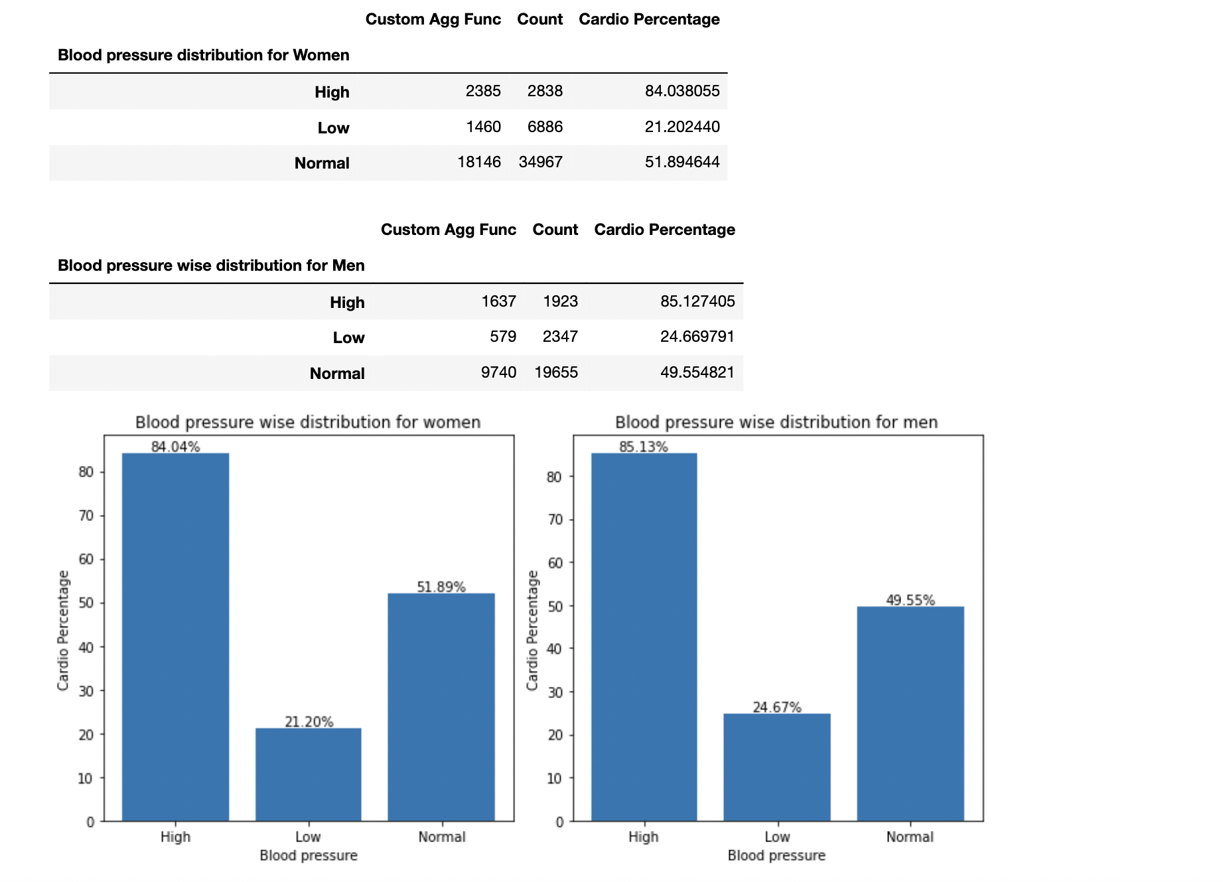

**FIG-5** Cardio percentage of people for men and women according to blood pressure.

**Conclusion**

1.We can observe here that women patients having high blood pressure are having 32.15 additional cases of cardio per 100 compared to normal women patients.

2.Men patients having high blood pressure are having 35.5 additional cases of cardio per 100 as compared to normal men patients.

3.We can conclude that high blood pressure plays key role in developing cardio vascular diseases.

4.Lifestyle changes: Person having high blood pressure should take precautions and medications before it will turn into permanent cardio problems.

**2. Comparing the factor of cholesterol**.

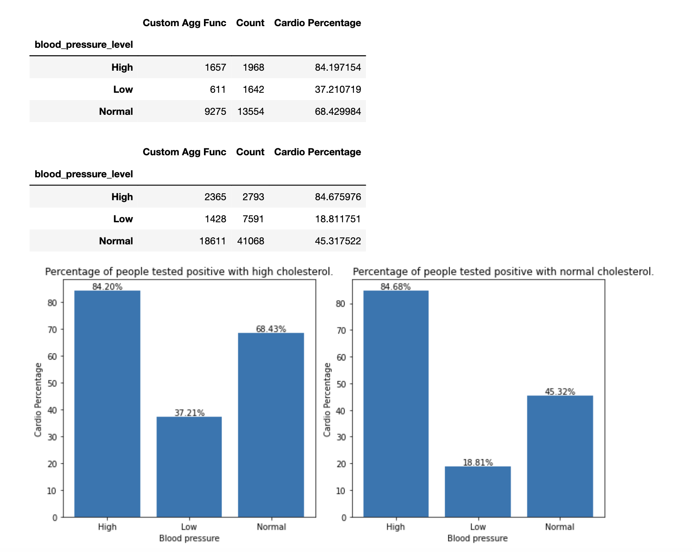

**FIG-6** Cardio percentage of people with high cholesterol according to blood pressure.

**Conclusion:**

1.Here we can observe that patients having normal blood pressure but high cholesterol are having 23.11 additional cases cardio per 100 compared to patients with normal BP and cholesterol.

2. Patients having low blood pressure with high cholesterol are having 18.4 additional cases of cardio per 100 compared to patients with low BP but normal cholesterol.

3.Patients with high blood pressure with high cholesterol is not giving significant differences. It might happen because high blood pressure is more significant factor than high cholesterol level.

4.Lifestyle changes: We can observe here that person having high cholesterol level are having more risk difference of cardio diseases. So, to reduce cholesterol level one should check their diet to prevent cardio vascular diseases.

**3.Patients with high cholesterol and bad lifestyle**

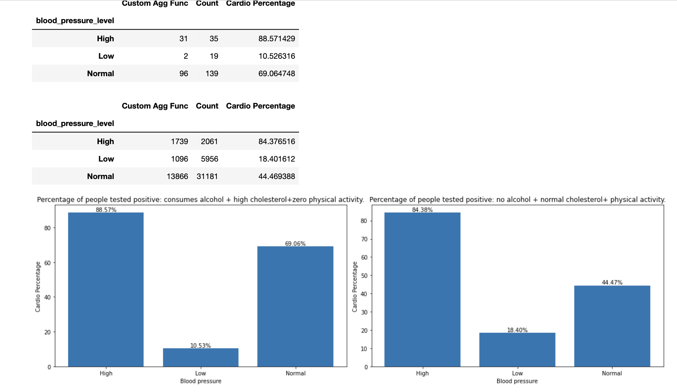

**Fig-7** Cardio percentage of people with high cholesterol and following bad lifestyle approaches of consuming alcohol and inactive physically according to the blood pressure.

**Conclusion**

1.Here we can observe that patients having normal blood pressure but high cholesterol with bad lifestyle approaches of consuming alcohol and not involving in any physical activity increases their risk difference by 24.59.

2.Patients having high blood pressure with bad lifestyle approaches are having 4.19 additional cases of cardio per 100 compared to people with high BP but following good lifestyle.

3.Lifestyle changes: Patients should approach good lifestyle by not consuming alcohol and involving in physical activity followed by good diet so that they can prevent cardio diseases.

**4.Patients with high cholesterol and glucose**

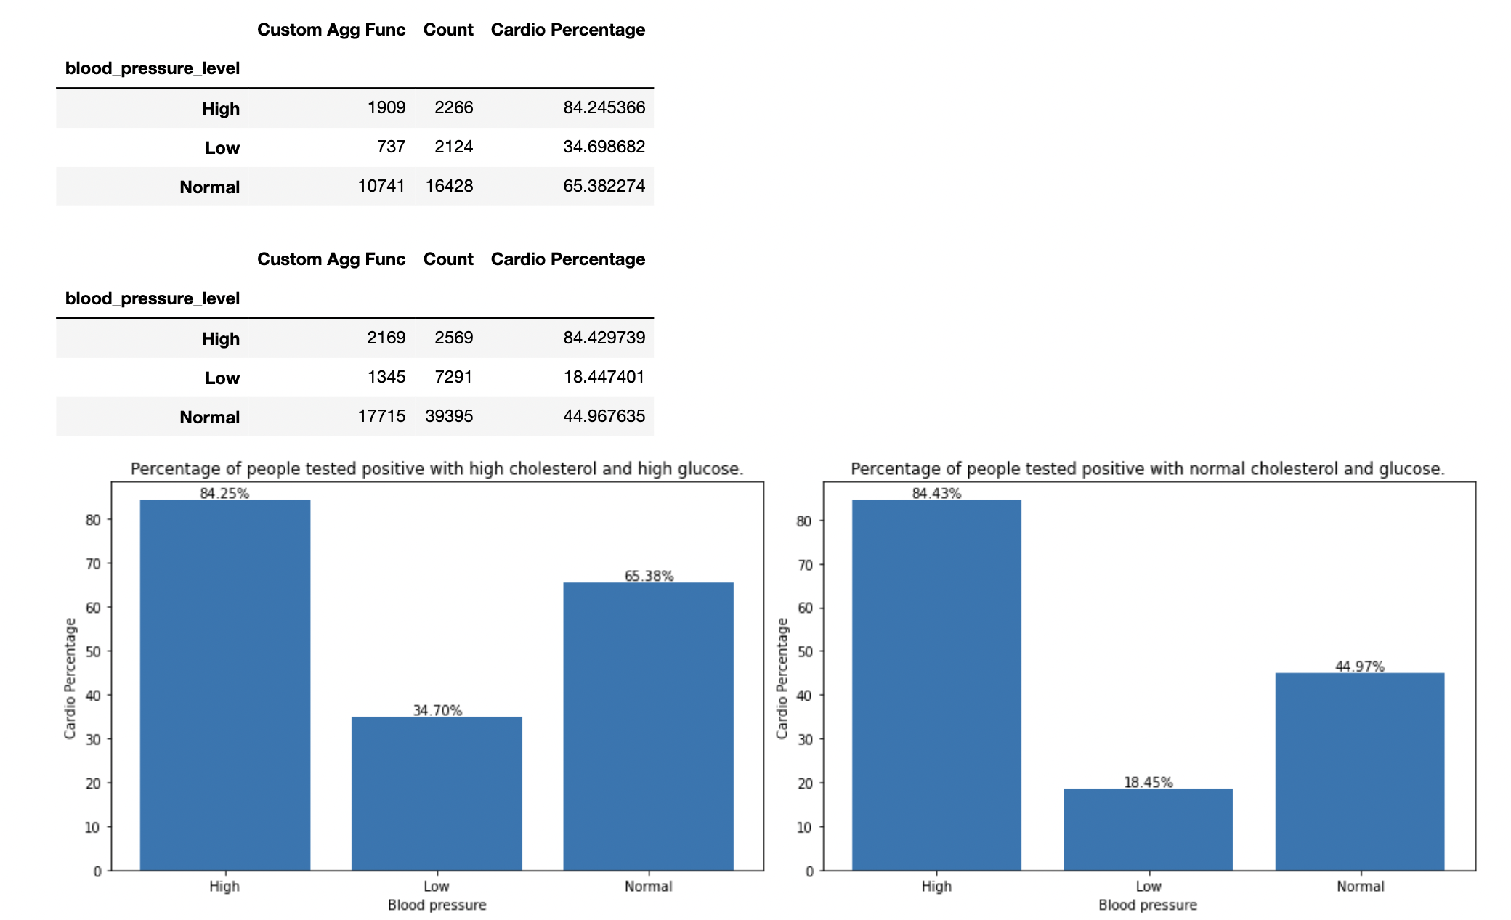

Fig-8 Cardio percentage of people with high cholesterol and high glucose according to blood pressure.

**Conclusion**

1.People having normal blood pressure but having high cholesterol and high glucose level increases the risk difference by 20.41 (20.41 additional cases of cardio per 100).

2.People having low blood pressure but having high cholesterol and high glucose level increases the risk difference by 16.25.

3.People having high blood pressure not showing any significant difference because high blood pressure itself is very significant factor.

4.Lifestyle changes: Person having normal blood pressure can prevent cardio diseases just by keeping their check on diet to control cholesterol and glucose.

### **8.3 BMI CLASS**

**1.BMI wise distribution for men and women.**

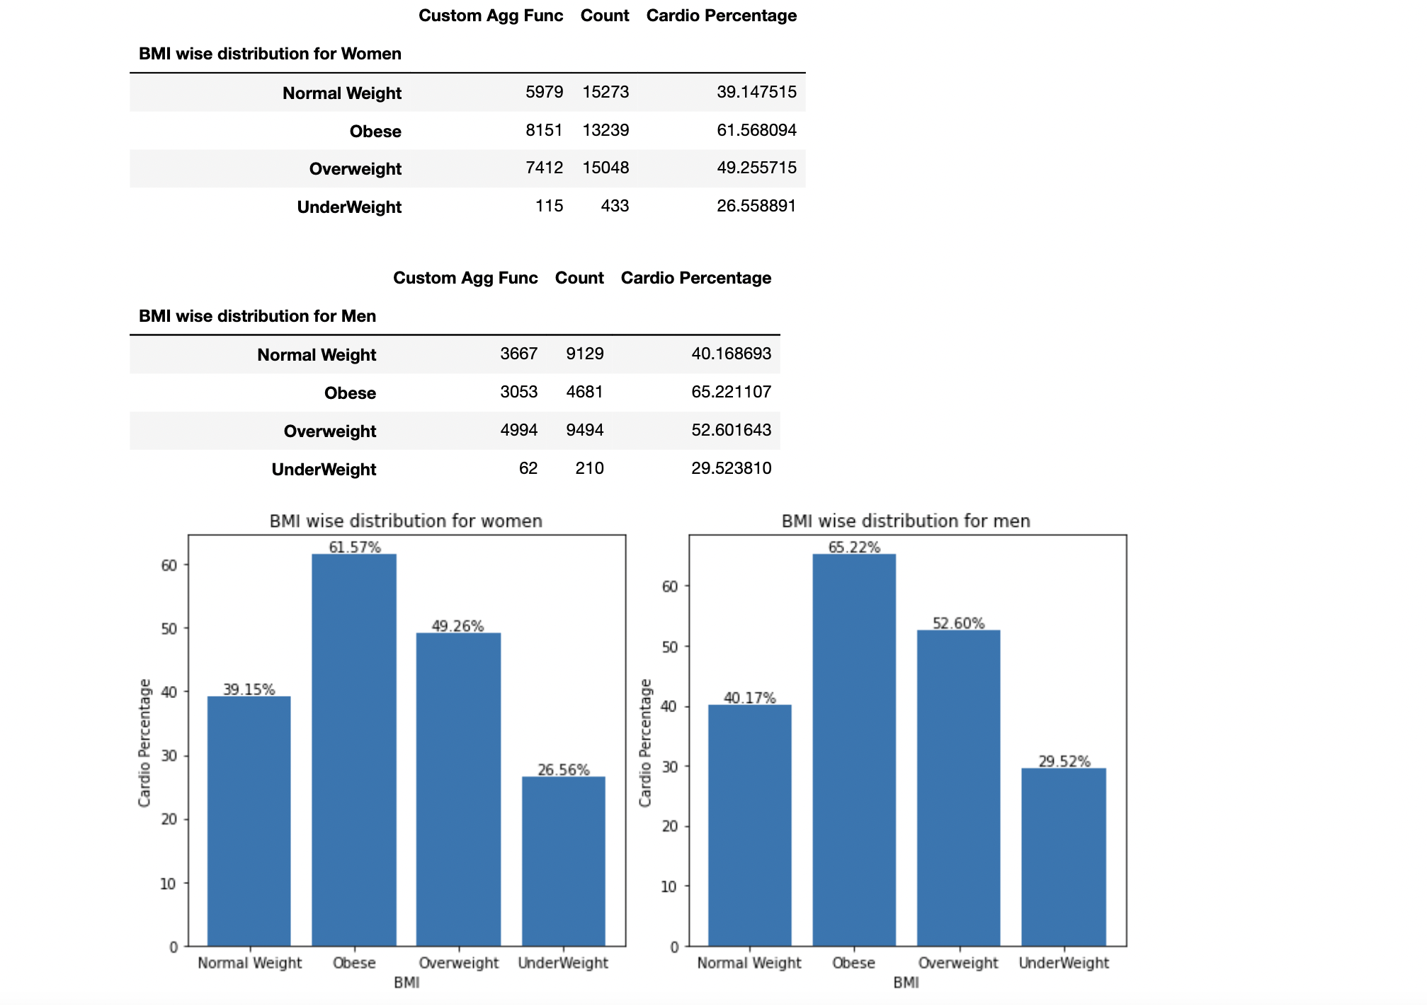

Fig-9 Cardio percentage of people for men and women according to BMI class.

**Conclusion**

1.Most cardio patients found in overweight and obese category.

2.If we observe, we can analyze obese category of women are having 22.42 additional cases of cardio per 100 compared to normal category of women.

3.In men category, obese are having 25.05 additional cases of cardio per 100 than normal category.

4.Lifestyle changes: Patients increases their risk difference of cardio by 22.42 in women and by 25.05 in men only by BMI factor. One must take proper precautions to maintain their BMI level.

**2.Patients with high cholesterol**

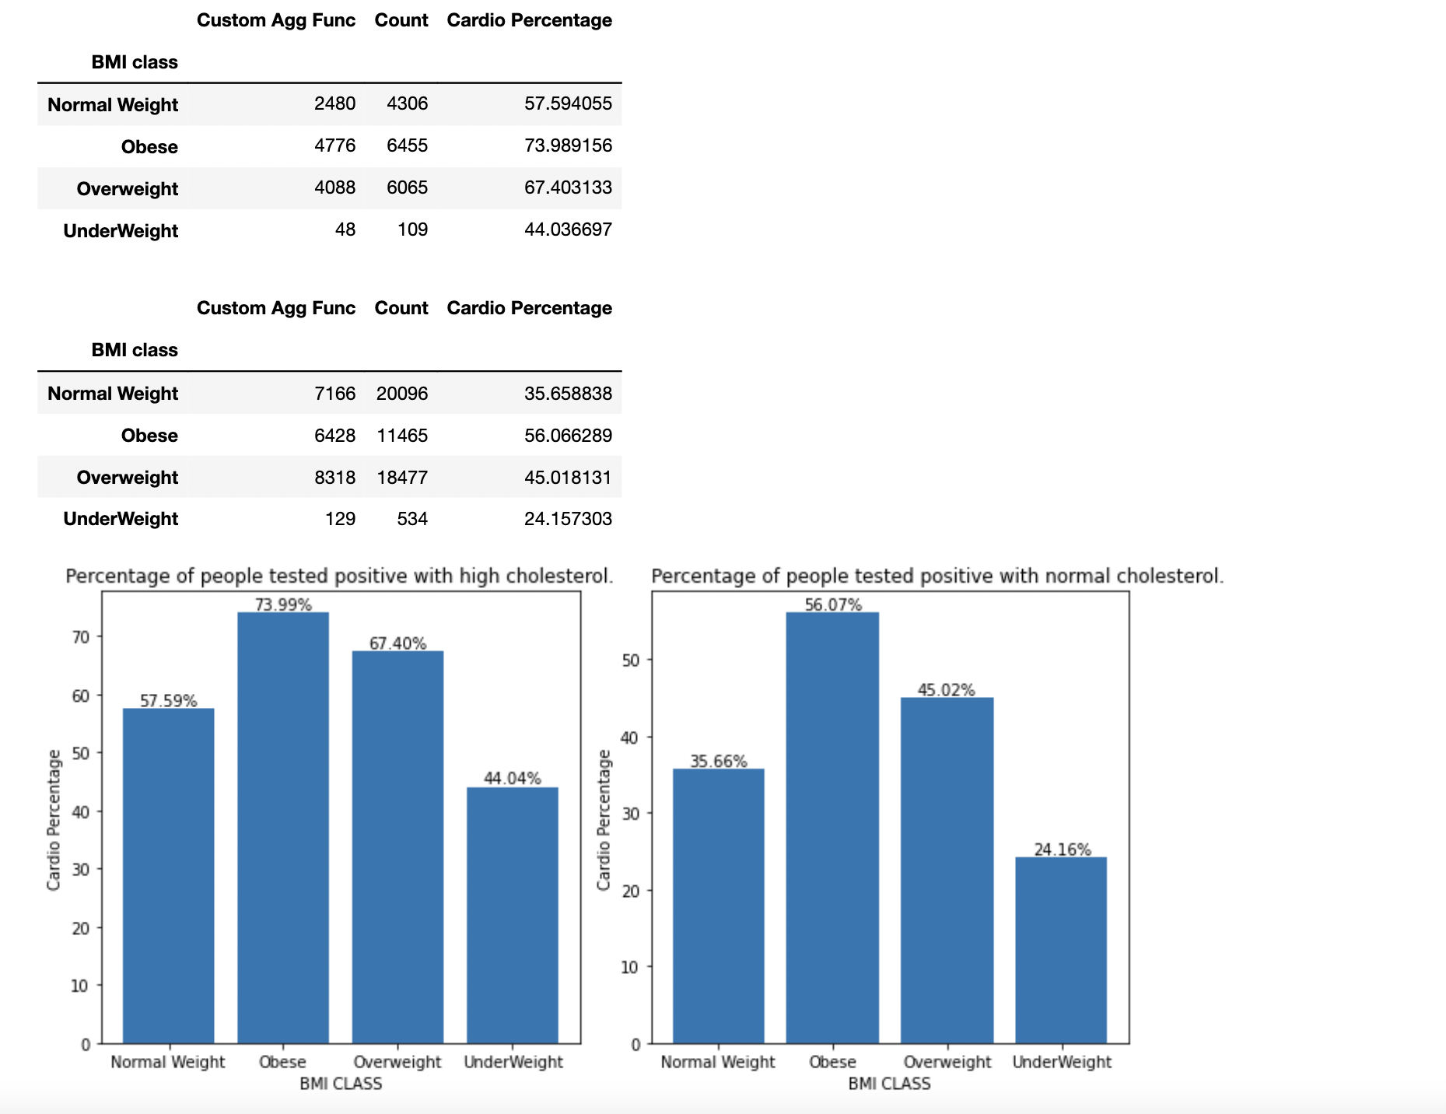

Fig-10 Cardio percentage of people with high cholesterol according to BMI class.

**CONCLUSION**

1. In Normal category: Patients with high cholesterol are having 21.93 additional cases of cardio per 100 compared to normal cholesterol patients.
2. In Overweight category: Patients with high cholesterol are having 22.38 additional cases of cardio per 100 compared to normal cholesterol patients.
3. In Obese category: Patients with high cholesterol are having 17.92 additional cases of cardio per 100 compared to normal cholesterol patients.
4. In Underweight category: Patients with high cholesterol are having 19.88 additional cases of cardio per 100 compared to normal cholesterol patients.
5. In every BMI class, cholesterol level is playing key role in developing cardio vascular diseases.
6. Lifestyle changes: Cholesterol factor increases the risk difference of cardio vascular diseases in every BMI class. One should follow healthy diet to prevent cardiovascular diseases.

**3.Patients with high cholesterol with bad lifestyle**

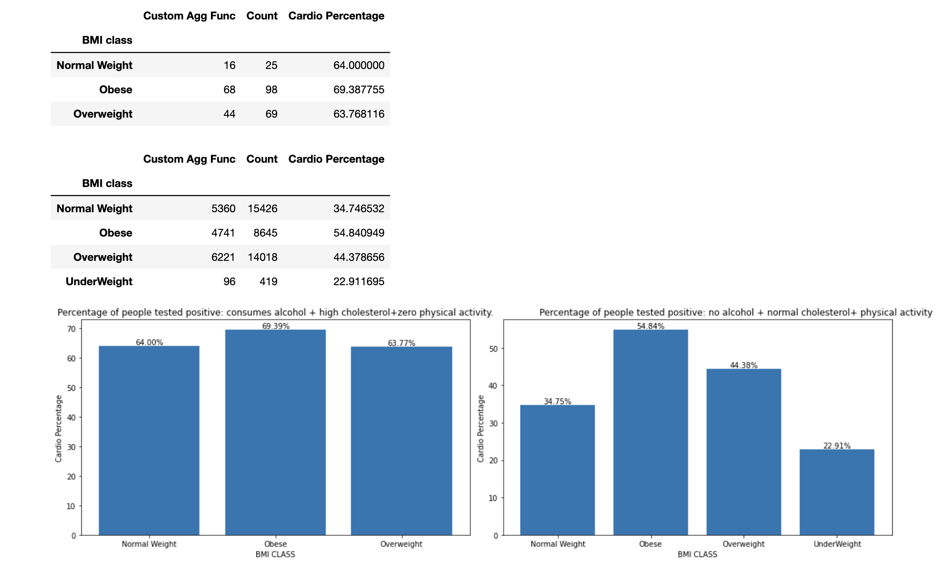

Fig-11 Cardio percentage of people with high cholesterol and following bad lifestyle approaches of consuming alcohol and inactive physically according to BMI class.

**Conclusion**

1.In Obese class: Patients with high cholesterol level and following bad approaches of lifestyle by consuming alcohol and not involved in any physical activity are having 14.55 additional cases of cardio per 100 compared to normal patients.

2.In Overweight class: Patients with high cholesterol level and following bad approaches of lifestyle by consuming alcohol and not involved in any physical activity are having 19.39 additional cases of cardio per 100 compared to normal patients.

3.In Normal class: Patients with high cholesterol level and following bad approaches of lifestyle by consuming alcohol and not involved in any physical activity are having 29.25 additional cases of cardio per 100 compared to normal patients

4.Lifestyle approaches: In all the three category, good lifestyle reduces the chance of cardio diseases specifically in normal BMI class because in obese and overweight class other complexity also arises.

**4.Patients with high cholesterol and glucose**

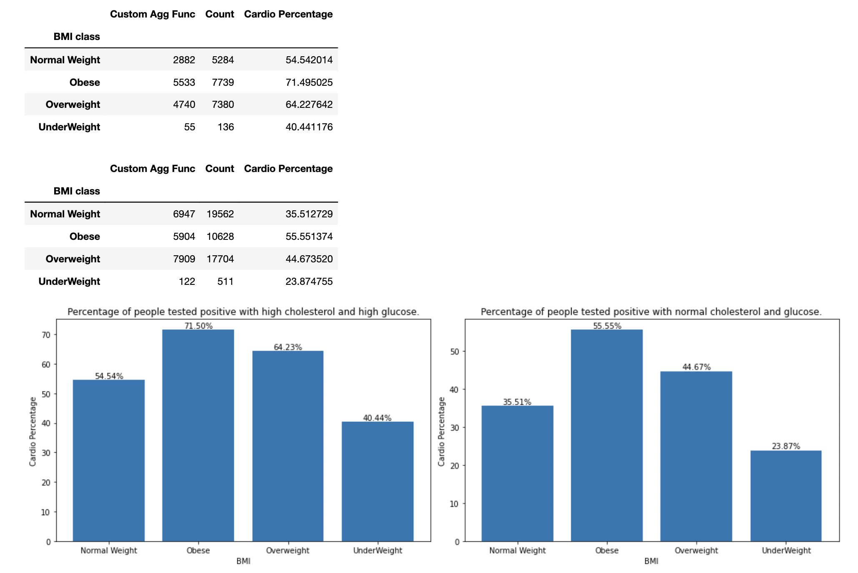

Fig-12 Cardio percentage of people with high cholesterol and high glucose according to the BMI class.

**Conclusion**

1.In Normal class: Patients with high cholesterol and glucose level are having 19.03 additional cases of cardio per 100 compared to patients with normal cholesterol and glucose level.

2.In Obese class: Patients with high cholesterol and glucose level are having 15.95 additional cases of cardio per 100 compared to patients with normal cholesterol and glucose level.

3.In Overweight class: Patients with high cholesterol and glucose level are having 19.56 additional cases of cardio per 100 compared to patients with normal cholesterol and glucose level.

4.In underweight class: Patients with high cholesterol and glucose level are having 16.57 additional cases of cardio per 100 compared to patients with normal cholesterol and glucose level.

5.Lifestyle changes: On an average, controlling the factors of glucose and cholesterol reduces the risk difference by 17.77 in all the classes of BMI.

### **8.4 BLOOD PRESSURE**

Blood pressure is typically measured in millimeters of mercury (mmHg) and consists of two numbers: systolic pressure over diastolic pressure. The systolic pressure represents the force exerted on the arterial walls when the heart contracts, while the diastolic pressure represents the force when the heart is at rest between beats.

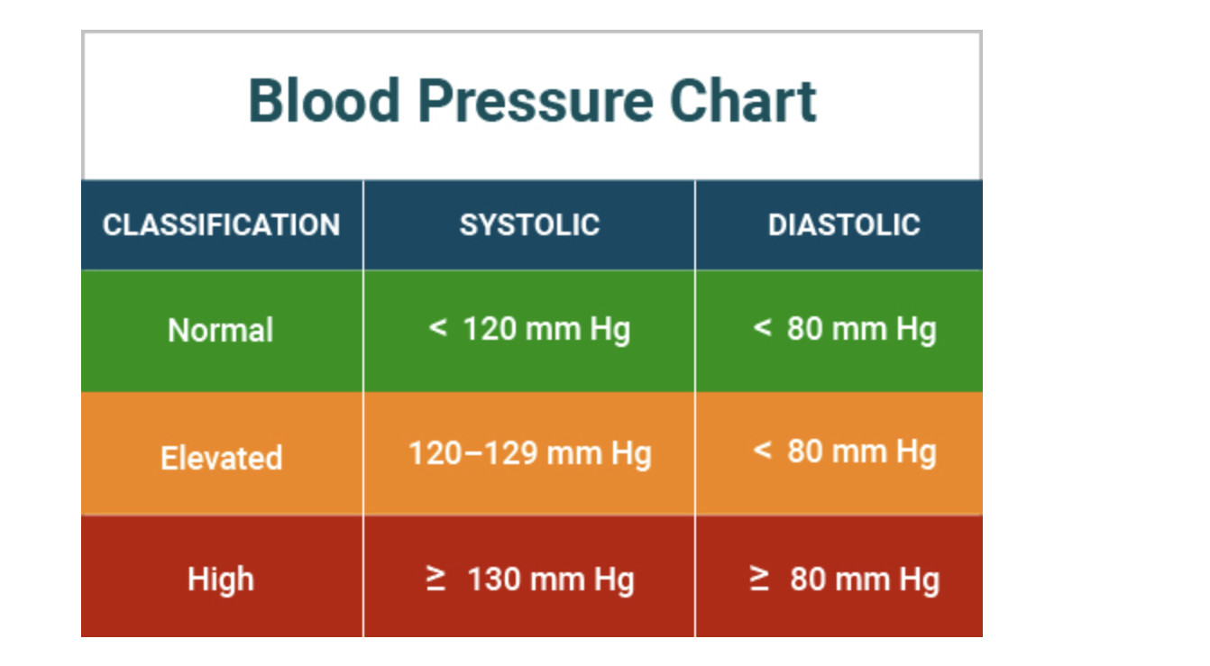

Source: www.medindia.net

### **8.5 bmi range**

Body Mass Index (BMI) is a commonly used measure to assess a person's weight status based on their height and weight. It provides a general indication of whether a person's weight is within a healthy range. The BMI is calculated by dividing a person's weight in kilograms by the square of their height in meters.

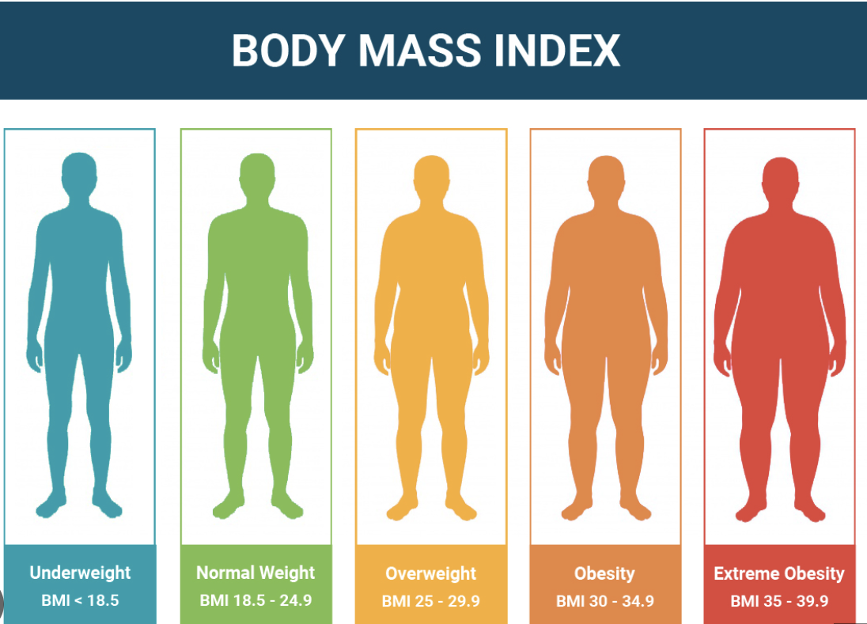

**Source**: [www.medindia.net](http://www.medindia.net)

### **Lifestyle changes summary**

1.On the basis of age group

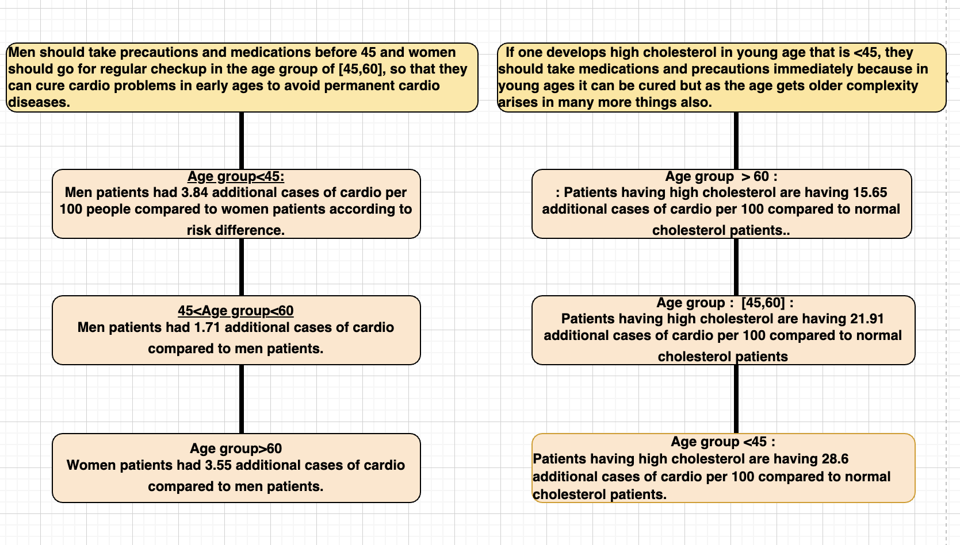

**According to Fig 1 According to Fig 2**

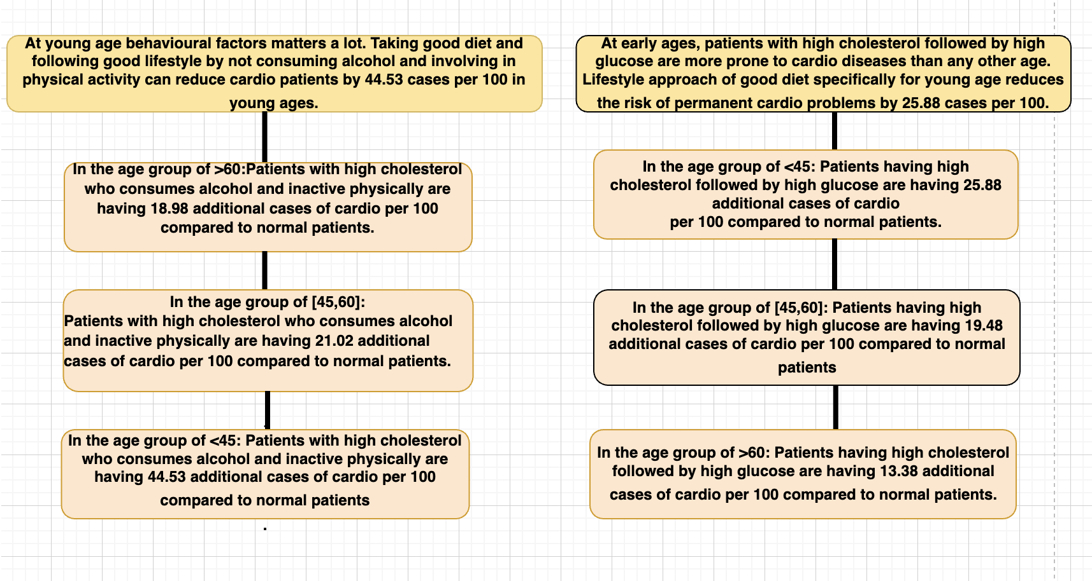

**According to Fig 3 According to Fig 4**

2.On the basis of blood pressure

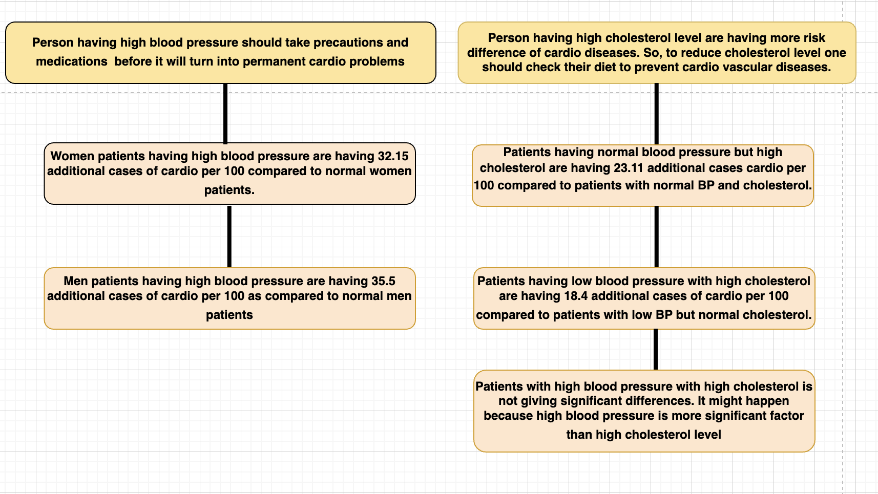

**According to Fig 5 According to Fig 6**

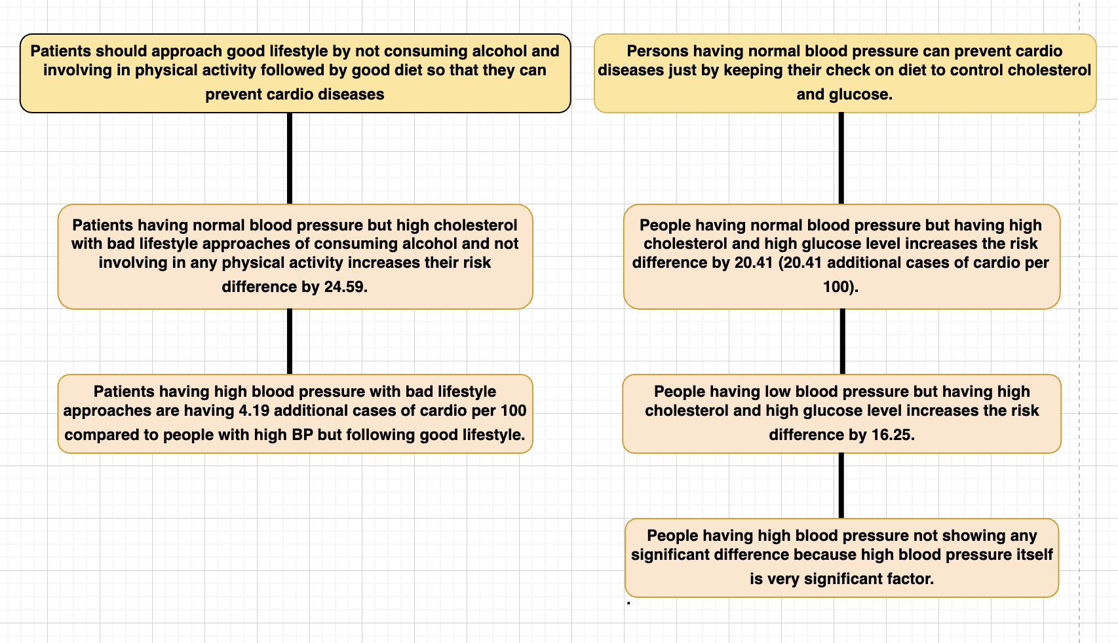

**According to Fig 7 According to Fig 8**

3.On the basis of BMI

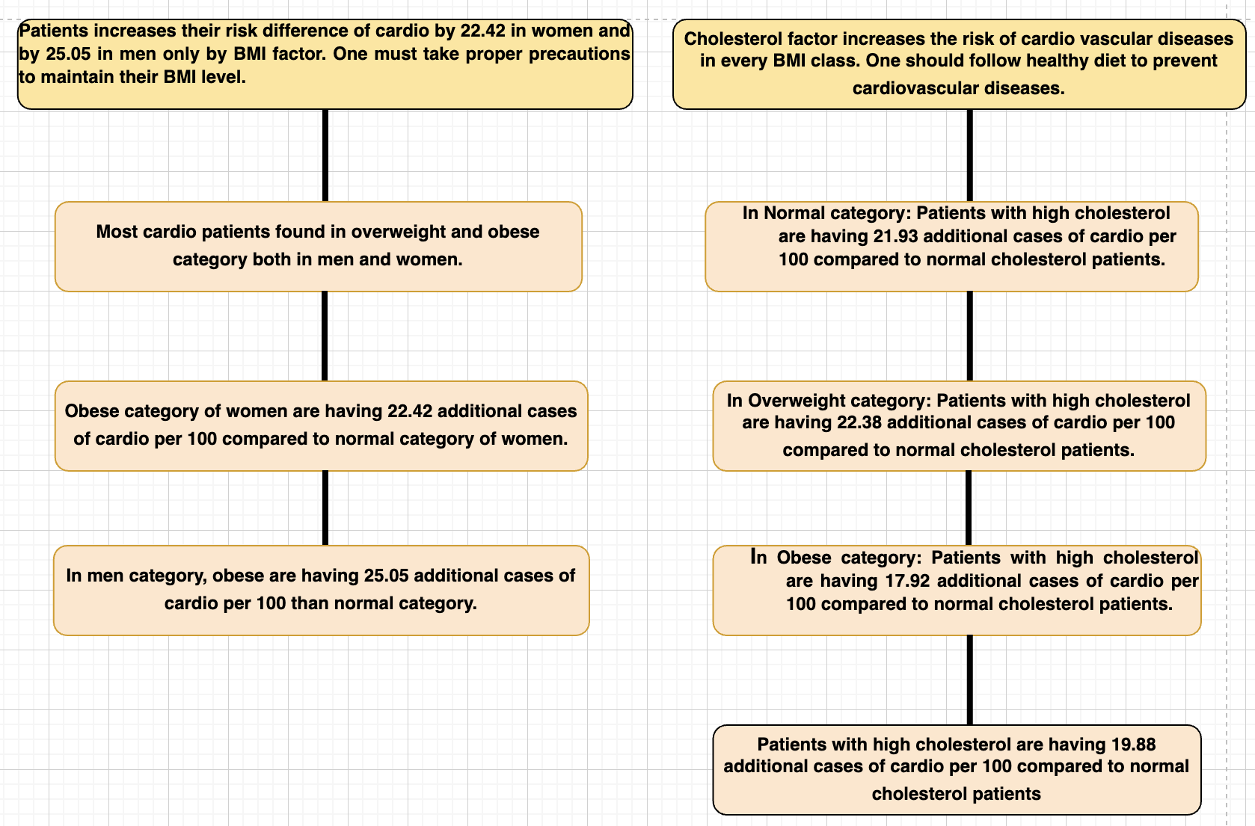

**According to Fig 9 According to Fig 10**

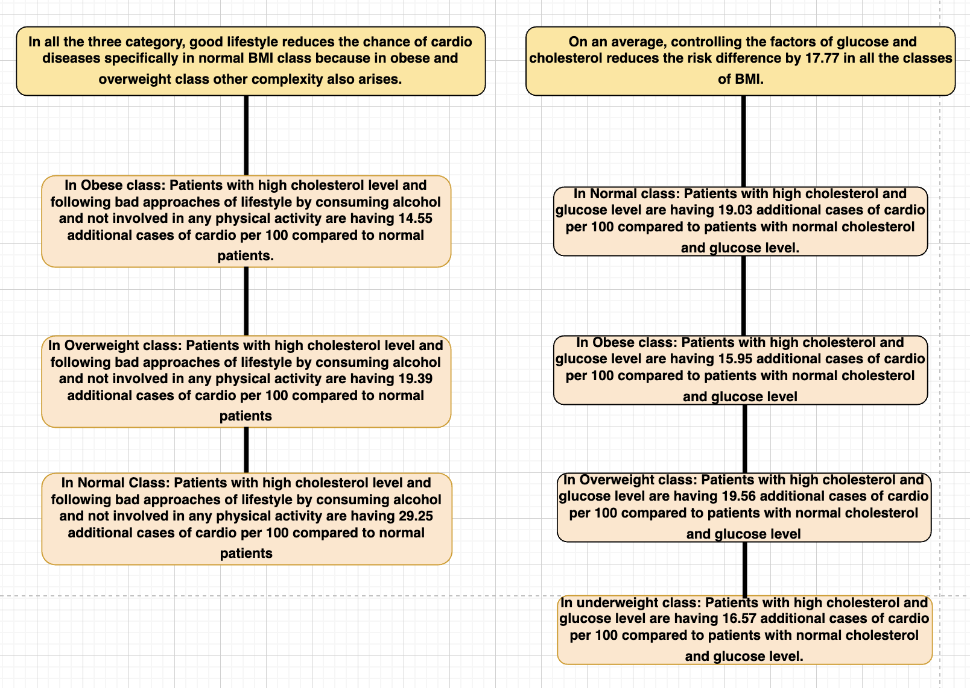

**According to Fig 11 According to Fig 12**

### **8.6 HEAT MAP**

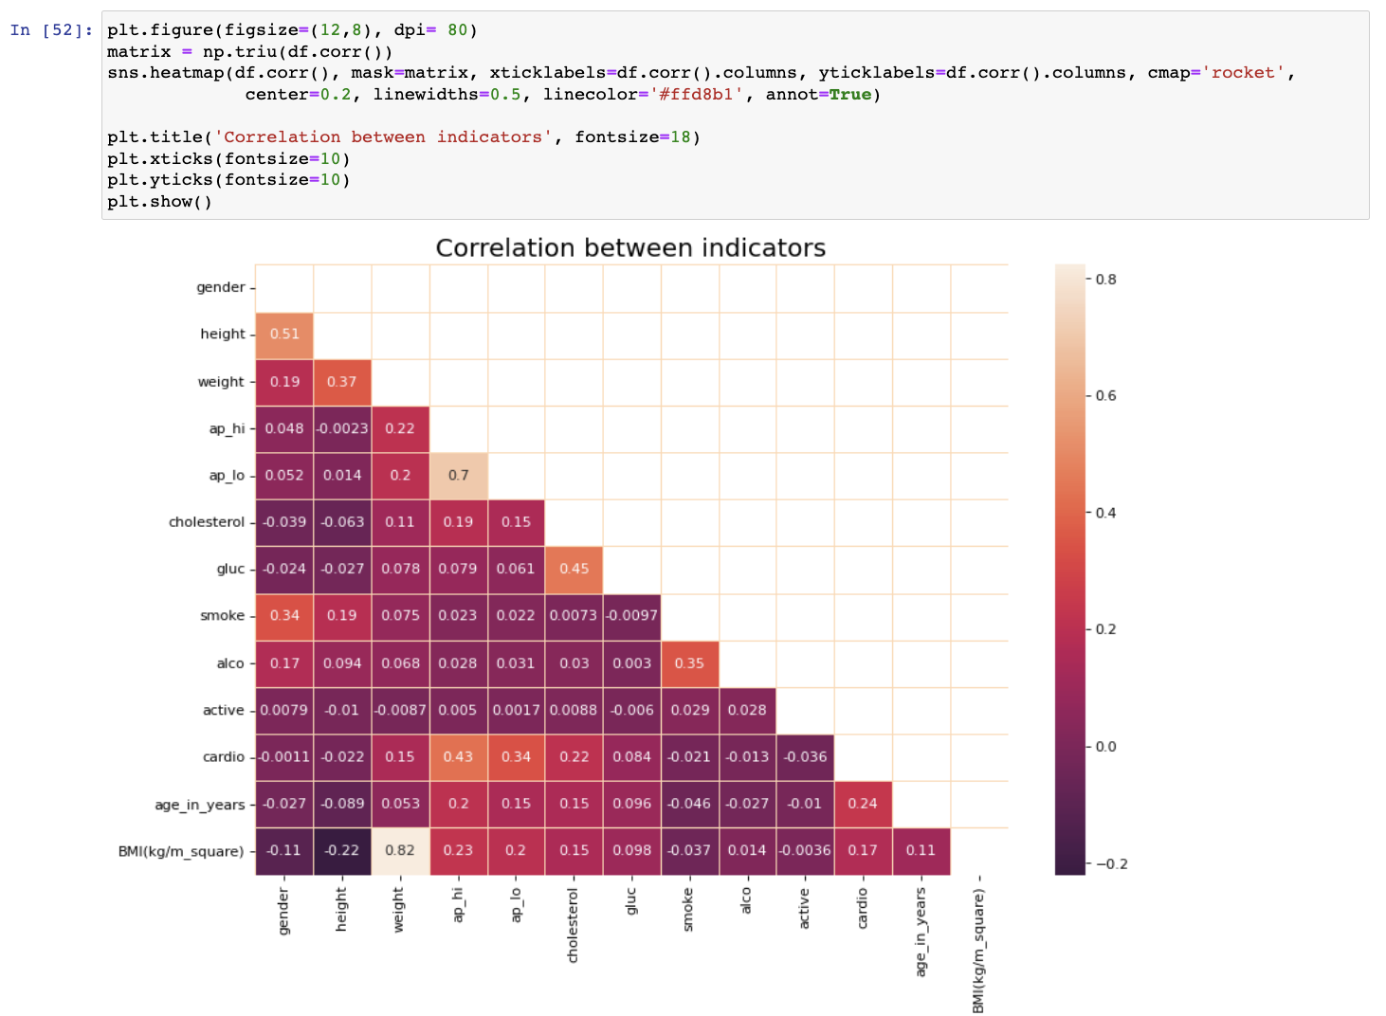

Plot shows how different indicators are correlated to each other.

High correlation between systolic and diastolic blood pressure, BMI and weight.

Moderately correlation between cholesterol and glucose, smoke and alcohol, cardio and systolic, cardio and diastolic.

Weak correlation between glucose and alcohol, BMI and height.

## **9. DATA PREPARATION FOR MODEL MAKING.**

### **Removing outliers**

Outliers are data points that significantly deviate from the overall pattern or distribution of a dataset. They are observations that are either unusually large or small compared to the majority of the data points. Outliers can occur due to various reasons, such as measurement errors, data entry mistakes, or genuine extreme values.

When analyzing data, it is important to identify and handle outliers appropriately, as they can have a significant impact on statistical analyses and modeling.

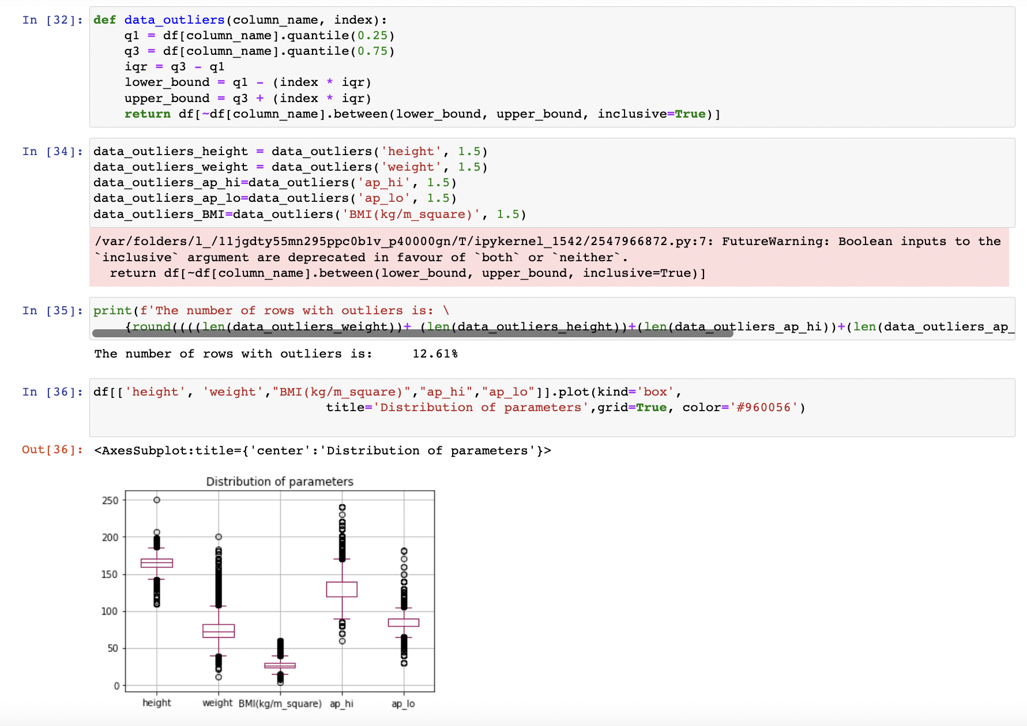

After removing the outliers.

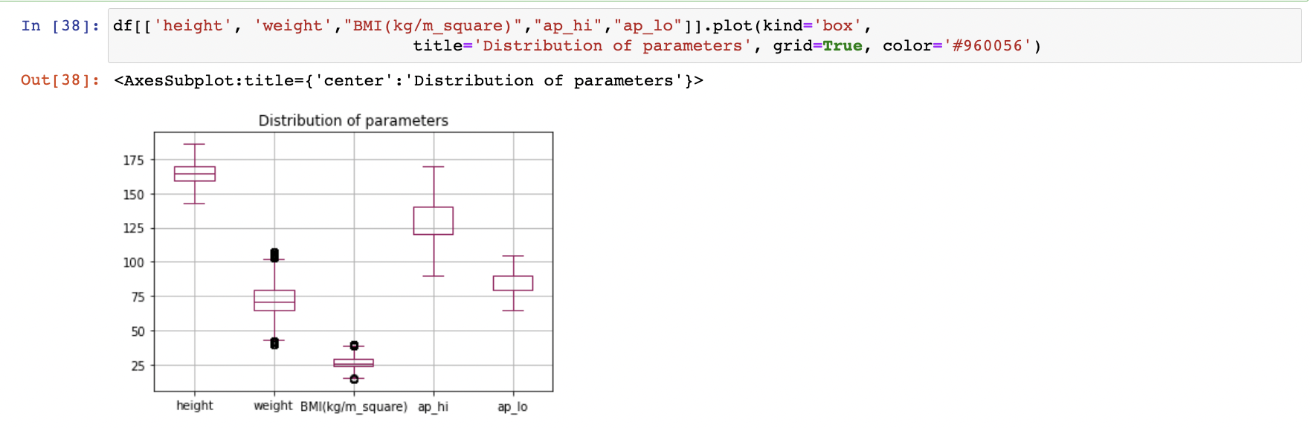

After refining the data more.

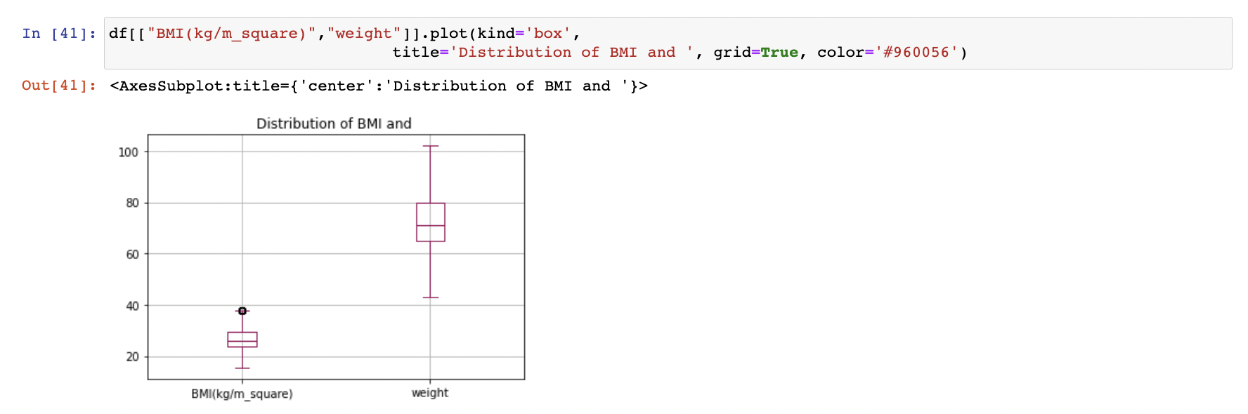

## **10.Predicting and Modelling**

### **1.Logistic regression**

Logistic regression is a statistical model used to predict binary or categorical outcomes based on one or more independent variables. It is commonly used in machine learning and statistical analysis for classification problems. Unlike linear regression, which predicts continuous numeric values, logistic regression predicts the probability of an event or the likelihood of belonging to a particular class.

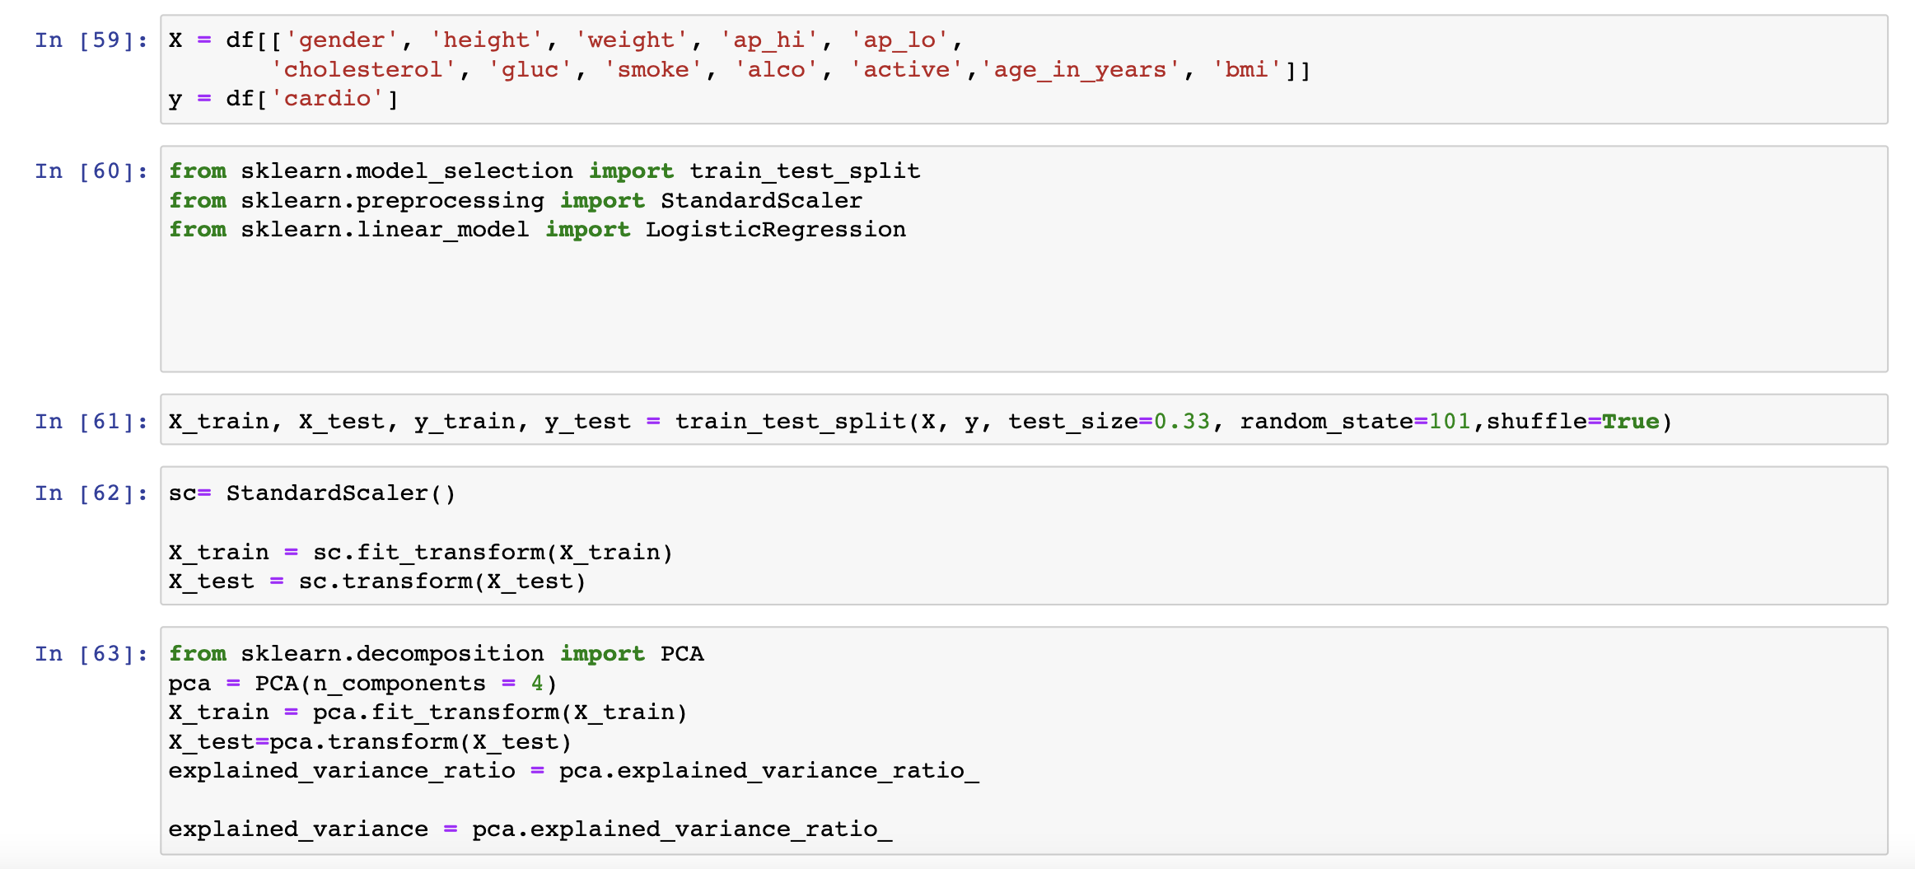

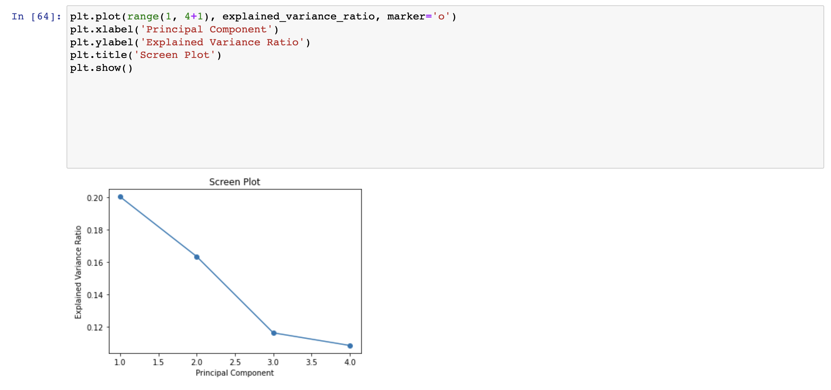

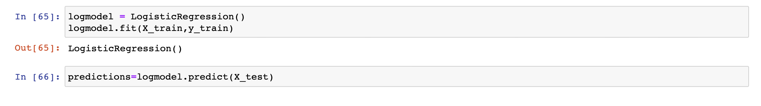

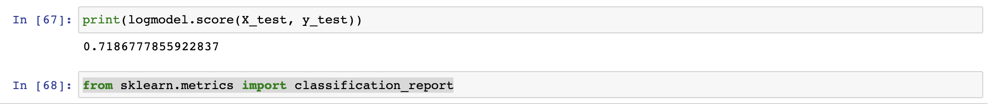

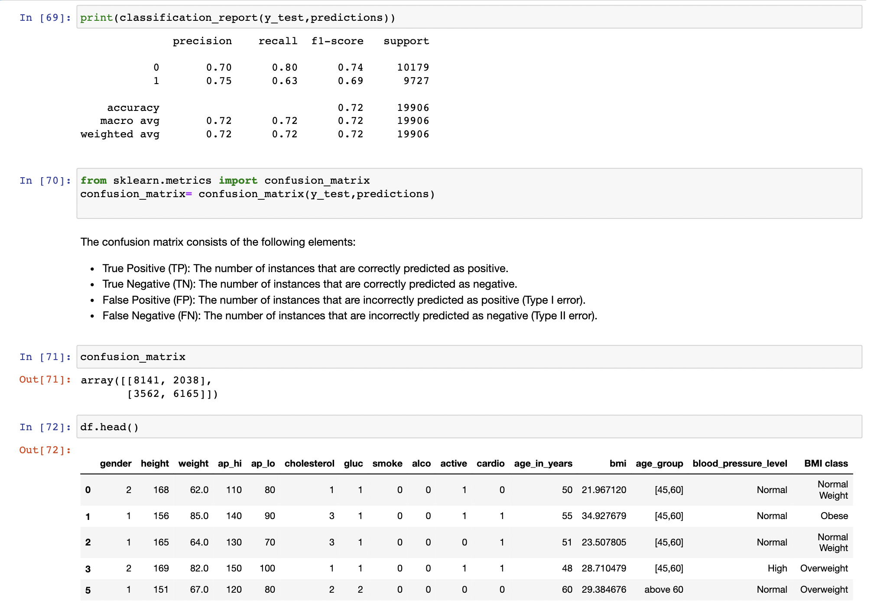

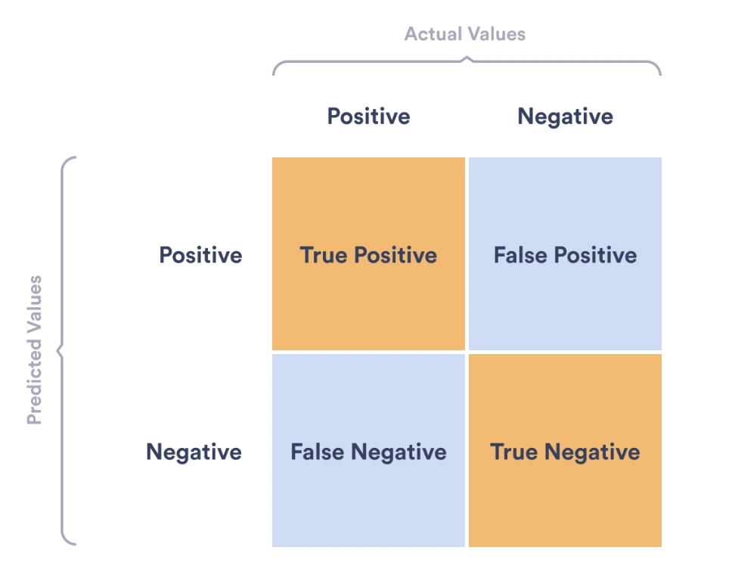

Results are satisfactory but to move towards better accuracy and precision we are moving ahead towards more models.

### **2.DECISION TREE**

A decision tree is a supervised machine learning algorithm that can be used for both classification and regression tasks. It is a flowchart-like model that makes decisions based on the values of input features to predict the value of a target variable.

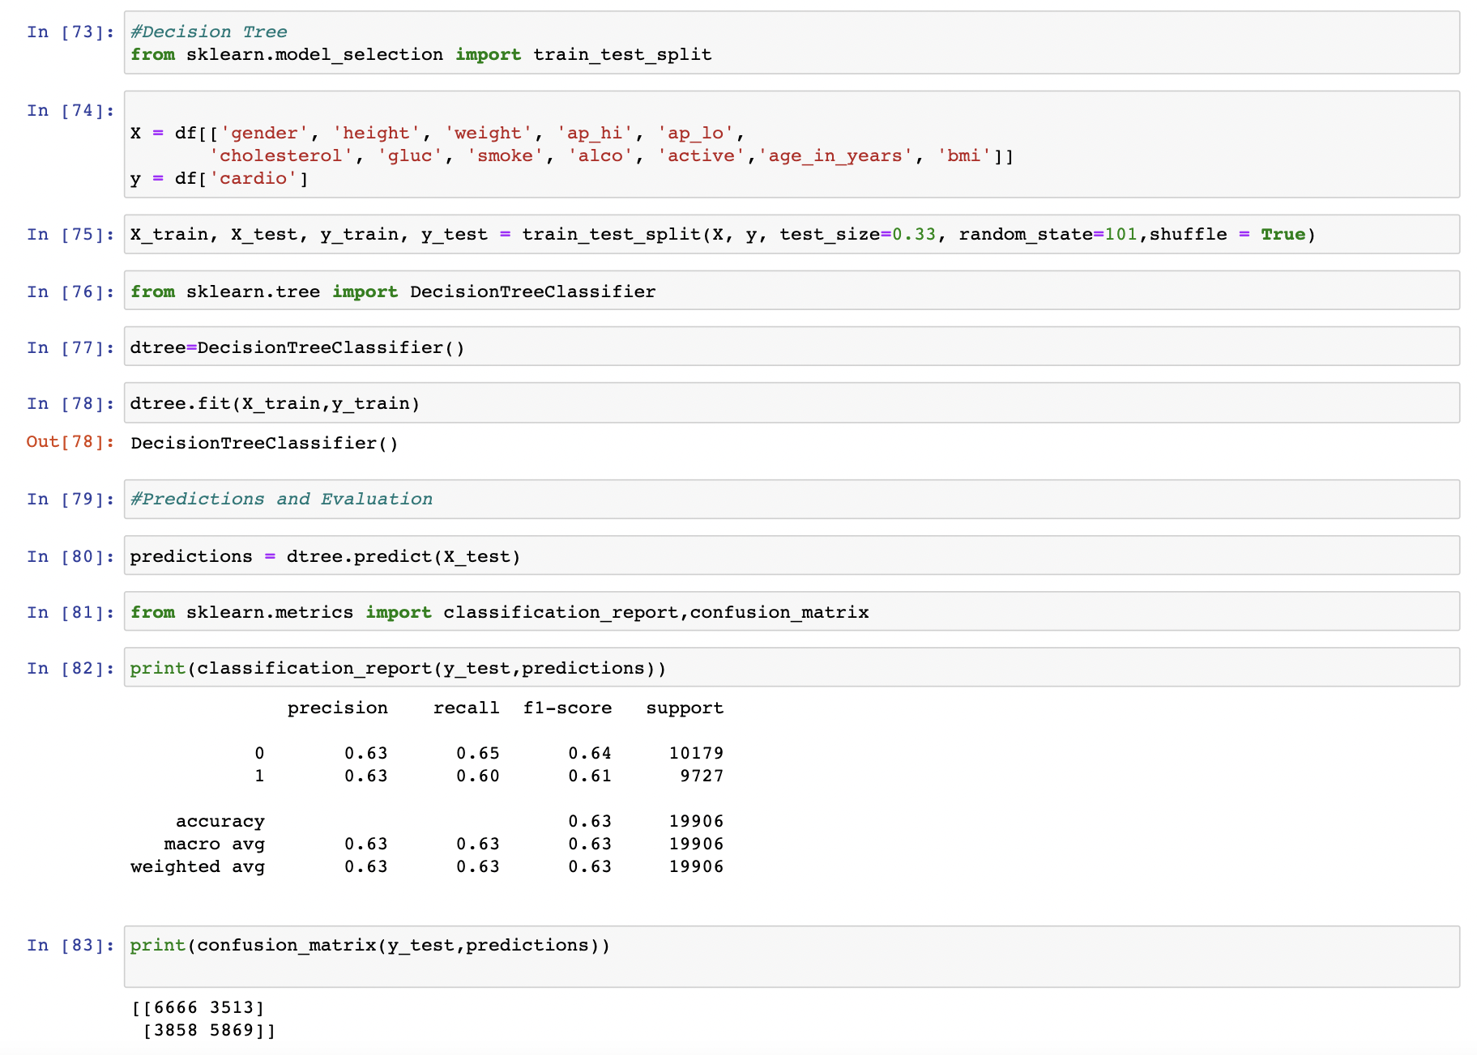

Accuracy and precision are lesser than logistic regression, so we are moving ahead towards random forest.

### **3.Random forest**

Random Forest is an ensemble learning algorithm that combines multiple decision trees to create a powerful predictive model. It is widely used for classification and regression tasks in machine learning.

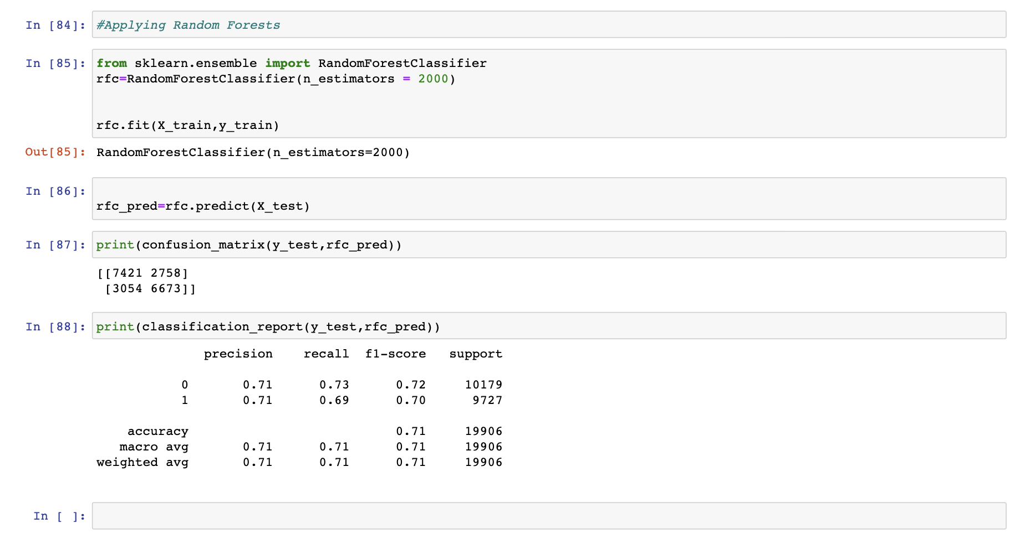

Results of classification report are satisfactory. Precision and accuracy is coming out as 0.71.

## **11.CONCLUSION**

The data analysis project on cardiovascular disease (CVD) had provided valuable insights into the risk factors and impact of lifestyle on CVD. By analyzing the data, I have identified several factors that contribute to CVD risk, including age, gender, blood pressure, cholesterol levels, smoking habits, alcohol consumption, and physical activity.

The findings suggest that individuals who engage in regular physical activity, maintain a healthy weight, and adopt healthy lifestyle habits have a lower risk of developing CVD.

The developed machine learning models have allowed for the prediction of CVD risk based on individual characteristics, providing a useful tool for identifying high-risk individuals who may benefit from preventive measures or early intervention.

Based on these findings, it is recommended to promote a healthy lifestyle, including regular physical activity, maintaining a healthy weight, avoiding smoking, and moderating alcohol consumption, as these actions can significantly reduce the risk of CVD.

Further research is warranted to explore additional variables, consider other potential risk factors, and investigate the long-term effects of interventions for preventing CVD.

Overall, this data analysis project highlights the importance of adopting healthy lifestyle habits and early detection in reducing the burden of cardiovascular disease and promoting cardiovascular health in the population.

## **12.LEARNING**

In this project, I have explored and researched into the topic of cardiovascular disease, then got to know various processes of data cleaning and processing, performed exploratory data analysis (EDA) in python in the dataset of CVD. Explored certain library and graphs in python.

I have explored various machine learning model and got to know about training and testing the data using that I have made model to predict the absence or presence of Cardio Vascular Disease.

Overall, this project highlights the importance of data analysis, machine learning, and lifestyle changes in cardiovascular disease prevention. It showcases the potential for using data-driven approaches to enhance risk assessment and support informed decision-making for better cardiovascular health.

## **13.BIBLIOGRAPHY**

1. [www.Kaggle.com](http://www.Kaggle.com)
2. [www.w3schools.com](http://www.w3schools.com)
3. [www.geeksforgeeks.org](http://www.geeksforgeeks.org)
4. [www.who.int](http://www.who.int)
5. [www.github.com](http://www.github.com)
6. An Introduction to machine learning by Miroslav Kubat.